2026

MPLS & VPLS Backbone Design based on Islington College Using GNS3 and MikroTik

MPLS & VPLS - PART 1

**SUBASH SUBEDI**

Project@suashsubedi0.com.np

**Scenario**

Islington College operates a multi-block campus network consisting of 9 academic and administrative blocks. The college owns a public IPv4 address range (160.30.132.0/24), which must be used for router loopback interfaces within an MPLS backbone.

We are required to design, implement, and verify an MPLS-based core network using MikroTik routers in GNS3, providing VPLS-based Layer-2 connectivity across all blocks while using a centralized DHCP server.

The LONDON_BLOCK is the main block, connected to the Internet (ISP), and all other blocks connect to it directly and via additional mesh links for redundancy and load balancing.

**Network Architecture and IP Addressing Plan:**

Core Design

* All block routers act as MPLS core routers
* OSPF is the IGP across all routers
* MPLS with LDP must be enabled on all core and mesh links
* ECMP / Load balancing must be implemented
* VPLS must be used to extend VLANs across all blocks
* No DHCP service should run on any router

Use the following explicit IP addressing scheme. All loopback addresses are from the public IPv4 range 160.30.132.0/24 (160.30.132.0 to 160.30.132.255). Do not use any other IPs for loopbacks or links.

**Block Routers and Loopback IPs**

* LONDON_BLOCK (main block, connected to ISP): Loopback IP 160.30.132.1/32
* UK_BLOCK: Loopback IP 160.30.132.11/32
* NEPAL_BLOCK: Loopback IP 160.30.132.12/32
* HIMAL_BLOCK: Loopback IP 160.30.132.13/32
* BRIT_BLOCK: Loopback IP 160.30.132.14/32
* SKILL_BLOCK: Loopback IP 160.30.132.15/32
* ALUMNI_BLOCK: Loopback IP 160.30.132.16/32
* KUMARI _BLOCK: Loopback IP 160.30.132.17/32

**Point-to-Point Links from LONDON_BLOCK (Private IPs, /30 subnets):**

* LONDON_BLOCK to UK_BLOCK: 10.0.0.0/30 (LONDON_BLOCK: 10.0.0.1, UK_BLOCK: 10.0.0.2)
* LONDON_BLOCK to NEPAL_BLOCK: 10.0.0.4/30 (LONDON_BLOCK: 10.0.0.5, NEPAL_BLOCK: 10.0.0.6)
* LONDON_BLOCK to HIMAL_BLOCK: 10.0.0.8/30 (LONDON_BLOCK: 10.0.0.9, HIMAL_BLOCK: 10.0.0.10)
* LONDON_BLOCK to BRIT_BLOCK: 10.0.0.12/30 (LONDON_BLOCK: 10.0.0.13, BRIT_BLOCK: 10.0.0.14)
* LONDON_BLOCK to SKILL_BLOCK: 10.0.0.16/30 (LONDON_BLOCK: 10.0.0.17, SKILL_BLOCK: 10.0.0.18)
* LONDON_BLOCK to KUMARI_BLOCK: 10.0.0.20/30 (LONDON_BLOCK: 10.0.0.21, KUMARI_BLOCK: 10.0.0.22)
* LONDON_BLOCK to ALUMNI_BLOCK: 10.0.0.24/30 (LONDON_BLOCK: 10.0.0.25, ALUMNI_BLOCK: 10.0.0.26)

**Mesh Connections (Router-to-Router Private IPs, /30 subnets for redundancy):**

* UK_BLOCK to NEPAL_BLOCK: 10.0.0.28/30 (UK_BLOCK: 10.0.0.29, NEPAL_BLOCK: 10.0.0.30)
* UK_BLOCK to HIMAL_BLOCK: 10.0.0.32/30 (UK_BLOCK: 10.0.0.34, HIMAL_BLOCK: 10.0.0.33)
* NEPAL_BLOCK to BRIT_BLOCK: 10.0.0.36/30 (NEPAL_BLOCK: 10.0.0.37, BRIT_BLOCK: 10.0.0.38)
* HIMAL_BLOCK to SKILL_BLOCK: 10.0.0.40/30 (HIMAL_BLOCK: 10.0.0.42, SKILL_BLOCK: 10.0.0.41)
* BRIT_BLOCK to KUMARI_BLOCK: 10.0.0.44/30 (BRIT_BLOCK: 10.0.0.46, KUMARI_BLOCK: 10.0.0.45)
* SKILL_BLOCK to ALUMNI_BLOCK: 10.0.0.48/30 (SKILL_BLOCK: 10.0.0.50, ALUMNI_BLOCK: 10.0.0.49)
* ALUMNI_BLOCK to KUMARI_BLOCK: 10.0.0.52/30 (ALUMNI_BLOCK: 10.0.0.53, KUMARI_BLOCK: 10.0.0.54)

**VLANs and End-Device Subnets (Provided by Centralized DHCP):**

* VLAN 100 (STUDENT): 172.16.0.0/19 (capacity for 5,000 student IPs)
* VLAN 200 (TEACHER): 172.16.32.0/19 (capacity for 1,000 teacher IPs)
* VLAN 300 (STAFF): 172.16.36.0/21 (capacity for 2,000 staff IPs)

**Table of Contents**

1. Set Identity, Loopback Address and RoMON to all Routers 1

1.1. LONDON-BLOCK 1

1.2. UK-BLOCK 1

1.3. NEPAL-BLOCK 2

1.4. HIMAL-BLOCK 3

1.5. BRIT-BLOCK 4

1.6. SKILL-BLOCK 5

1.7. ALUMNI-BLOCK 6

1.8. KUMARI-BLOCK 6

2. Set description on the Interface to all router 8

2.1. LONDON-BLOCK 8

2.2. UK-BLOCK 8

2.3. NEPAL-BLOCK 8

2.4. HIMAL-BLOCK 8

2.5. BRIT-BLOCK 9

2.6. SKILL-BLOCK 9

2.7. ALUMNI-BLOCK 9

2.8. KUMARI-BLOCK 10

3. Configuration IP in the Core Interface of all Routers 11

3.1. LONDON-BLOCK 11

3.2. UK-BLOCK 12

3.3. NEPAL-BLOCK 13

3.4. HIMAL-BLOCK 14

3.5. BRIT-BLOCK 15

3.6. SKILL-BLOCK 16

3.7. ALUMNI-BLOCK 17

3.8. KUMARI-BLOCK 18

4. Configuration OSPF to all Core Routers 20

4.1. LONDON-BLOCK 20

4.2. UK-BLOCK 23

4.3. NEPAL-BLOCK 25

4.4. HIMAL-BLOCK 27

4.5. BRIT-BLOCK 29

4.6. SKILL-BLOCK 31

4.7. ALUMNI-BLOCK 33

4.8. KUMARI-BLOCK 35

5. Configure Management Access from PC to MPLS Loopback 37

5.1. PC (VMware Host) – Static Route Configuration 37

5.2. UK-BLOCK – OSPF Configuration (No Management Network Advertisement) 37

5.3. Disable RoMON temporarily to avoid confusion 38

5.4. End-to-End Verification (From PC) 38

6. Configuration MPLS to all Core Routers 39

6.1. LONDON-BLOCK 39

6.2. UK-BLOCK 39

6.3. NEPAL-BLOCK 40

6.4. HIMAL-BLOCK 41

6.5. BRIT-BLOCK 42

6.6. SKILL-BLOCK 42

6.7. ALUMNI-BLOCK 43

6.8. KUMARI-BLOCK 44

7. MPLS & LDP Configuration on Core Interfaces (with MTU) 45

7.1. LONDON-BLOCK 45

7.1.1. Enable LDP on Core Interfaces ONLY 45

7.1.2. Enable MPLS & Set MPLS MTU on interfaces 46

7.2. UK-BLOCK 47

7.2.1. Enable LDP on Core Interfaces ONLY 47

7.2.2. Enable MPLS & Set MPLS MTU on interfaces 47

7.3. NEPAL-BLOCK 48

7.3.1. Enable LDP on Core Interfaces ONLY 48

7.3.2. Enable MPLS & Set MPLS MTU on interfaces 49

7.4. HIMAL-BLOCK 50

7.4.1. Enable LDP on Core Interfaces ONLY 50

7.4.2. Enable MPLS & Set MPLS MTU on interfaces 50

7.5. BRIT-BLOCK 51

7.5.1. Enable LDP on Core Interfaces ONLY 51

7.5.2. Enable MPLS & Set MPLS MTU on interfaces 52

7.6. SKILL-BLOCK 53

7.6.1. Enable LDP on Core Interfaces ONLY 53

7.6.2. Enable MPLS & Set MPLS MTU on interfaces 54

7.7. ALUMNI-BLOCK 55

7.7.1. Enable LDP on Core Interfaces ONLY 55

7.7.2. Enable MPLS & Set MPLS MTU on interfaces 56

7.8. KUMARI-BLOCK 57

7.8.1. Enable LDP on Core Interfaces ONLY 57

7.8.2. Enable MPLS & Set MPLS MTU on interfaces 58

**List of Figures**

Figure 1: Set Identity, Loopback Address and RoMoN of LONDON_BLOCK Router Through CMD 1

Figure 2: Set Identity, Loopback Address and RoMoN of LONDON_BLOCK Router Through WINBOX 1

Figure 3: Set Identity, Loopback Address and RoMoN of UK-BLOCK Router Through CMD 2

Figure 4: Set Identity, Loopback Address and RoMoN of UK-BLOCK Router Through WINBOX 2

Figure 5: Set Identity, Loopback Address and RoMoN of NEPAL-BLOCK Router Through CMD 3

Figure 6: Set Identity, Loopback Address and RoMoN of NEPAL-BLOCK Router Through WINBOX 3

Figure 7: Set Identity, Loopback Address and RoMoN of NEPAL-BLOCK Router Through CMD 4

Figure 8: Set Identity, Loopback Address and RoMoN of NEPAL-BLOCK Router Through WINBOX 4

Figure 9: Set Identity, Loopback Address and RoMoN of BRIT-BLOCK Router Through CMD 5

Figure 10: Set Identity, Loopback Address and RoMoN of BRIT-BLOCK Router Through WINBOX 5

Figure 11: Set Identity, Loopback Address and RoMoN of SKILL-BLOCK Router Through CMD 6

Figure 12: Set Identity, Loopback Address and RoMoN of SKILL-BLOCK Router Through WINBOX 6

Figure 13: Set Identity, Loopback Address and RoMoN of ALUMNI-BLOCK Router Through CMD 6

Figure 14: Set Identity, Loopback Address and RoMoN of ALUMNI-BLOCK Router Through WINBOX 6

Figure 15: Set Identity, Loopback Address and RoMoN of KUMARI-BLOCK Router Through CMD 7

Figure 16: Set Identity, Loopback Address and RoMoN of KUMARI-BLOCK Router Through WINBOX 7

Figure 17: Configuration IP in the Core Interface of LONDON-BLOCK Router Through CMD 11

Figure 18: Configuration IP in the Core Interface of LONDON-BLOCK Router Through WINBOX 12

Figure 19: Configuration IP in the Core Interface of UK-BLOCK Router Through CMD 12

Figure 20: Configuration IP in the Core Interface of UK-BLOCK Router Through WINBOX 13

Figure 21: Configuration IP in the Core Interface of NEPAL-BLOCK Router Through CMD 13

Figure 22: Configuration IP in the Core Interface of NEPAL-BLOCK Router Through WINBOX 14

Figure 23: Configuration IP in the Core Interface of HIMAL-BLOCK Router Through CMD 14

Figure 24: Configuration IP in the Core Interface of HIMAL-BLOCK Router Through WINBOX 15

Figure 25: Configuration IP in the Core Interface of BRIT-BLOCK Router Through CMD 15

Figure 26: Configuration IP in the Core Interface of BRIT-BLOCK Router Through WINBOX 16

Figure 27: Configuration IP in the Core Interface of SKILL-BLOCK Router Through CMD 16

Figure 28: Configuration IP in the Core Interface of SKILL-BLOCK Router Through WINBOX 17

Figure 29: Configuration IP in the Core Interface of ALUMNI-BLOCK Router Through CMD 17

Figure 30: Configuration IP in the Core Interface of ALUMNI-BLOCK Router Through WINBOX 18

Figure 31: Configuration IP in the Core Interface of KUMARI-BLOCK Router Through CMD 18

Figure 32: Configuration IP in the Core Interface of KUMARI-BLOCK Router Through WINBOX 19

Figure 33: Configuration OSPF to Core LONDON-BLOCK Router Through CMD 21

Figure 34: Configuration OSPF Instances to Core LONDON-BLOCK Router Through WINBOX 22

Figure 35: Configuration OSPF Area to Core LONDON-BLOCK Router Through WINBOX 22

Figure 36: Configuration OSPF Interface-template to Core LONDON-BLOCK Router Through WINBOX 22

Figure 37: Configuration OSPF to UK-BLOCK Router Through CMD 23

Figure 38: Configuration OSPF Instances to UK-BLOCK Router Through WINBOX 24

Figure 39: Configuration OSPF Area to UK-BLOCK Router Through WINBOX 24

Figure 40: Configuration OSPF Interface-template to UK-BLOCK Router Through WINBOX 24

Figure 41: Configuration OSPF to NEPAL-BLOCK Router Through CMD 25

Figure 42: Configuration OSPF Instances to NEPAL-BLOCK Router Through WINBOX 26

Figure 43: Configuration OSPF Area to NEPAL-BLOCK Router Through WINBOX 26

Figure 44: Configuration OSPF Interface-template to NEPAL-BLOCK Router Through WINBOX 26

Figure 45: Configuration OSPF to HIMAL-BLOCK Router Through CMD 27

Figure 46: Configuration OSPF Instances to HIMAL-BLOCK Router Through WINBOX 28

Figure 47: Configuration OSPF Area to HIMAL-BLOCK Router Through WINBOX 28

Figure 48: Configuration OSPF Interface-template to HIMAL-BLOCK Router Through WINBOX 28

Figure 49: Configuration OSPF to BRIT-BLOCK Router Through CMD 29

Figure 50: Configuration OSPF Instances to BRIT-BLOCK Router Through WINBOX 30

Figure 51: Configuration OSPF Area to BRIT-BLOCK Router Through WINBOX 30

Figure 52: Configuration OSPF Interface-template to BRIT-BLOCK Router Through WINBOX 30

Figure 53: Configuration OSPF to SKILL-BLOCK Router Through CMD 31

Figure 54: Configuration OSPF Instances to SKILL-BLOCK Router Through WINBOX 32

Figure 55: Configuration OSPF Area to SKILL-BLOCK Router Through WINBOX 32

Figure 56: Configuration OSPF Interface-template to SKILL-BLOCK Router Through WINBOX 32

Figure 57: Configuration OSPF to ALUMNI-BLOCK Router Through CMD 33

Figure 58: Configuration OSPF Instances to ALUMNI-BLOCK Router Through WINBOX 34

Figure 59: Configuration OSPF Area to ALUMNI-BLOCK Router Through WINBOX 34

Figure 60: Configuration OSPF Interface-template to ALUMNI-BLOCK Router Through WINBOX 34

Figure 61: Configuration OSPF to KUMARI-BLOCK Router Through CMD 35

Figure 62: Configuration OSPF Instances to KUMARI-BLOCK Router Through WINBOX 36

Figure 63: Configuration OSPF Area to KUMARI-BLOCK Router Through WINBOX 36

Figure 64: Configuration OSPF Interface-template to KUMARI-BLOCK Router Through WINBOX 36

Figure 65: Configuration MPLS to LONDON-BLOCK Router Through CMD 39

Figure 66: Configuration MPLS to LONDON-BLOCK Router Through WINBOX 39

Figure 67: Configuration MPLS to UK-BLOCK Router Through CMD 40

Figure 68: Configuration MPLS to UK-BLOCK Router Through WINBOX 40

Figure 69: Configuration MPLS to NEPAL-BLOCK Router Through CMD 40

Figure 70: Configuration MPLS to NEPAL-BLOCK Router Through WINBOX 41

Figure 71: Configuration MPLS to HIMAL-BLOCK Router Through CMD 41

Figure 72: Configuration MPLS to HIMAL-BLOCK Router Through WINBOX 41

Figure 73: Configuration MPLS to BRIT-BLOCK Router Through CMD 42

Figure 74: Configuration MPLS to BRIT-BLOCK Router Through WINBOX 42

Figure 75: Configuration MPLS to SKILL-BLOCK Router Through CMD 42

Figure 76: Configuration MPLS to SKILL-BLOCK Router Through WINBOX 43

Figure 77: Configuration MPLS to ALUMNI-BLOCK Router Through CMD 43

Figure 78: Configuration MPLS to ALUMNI-BLOCK Router Through WINBOX 44

Figure 79: Configuration MPLS to KUMARI-BLOCK Router Through CMD 44

Figure 80: Configuration MPLS to KUMARI-BLOCK Router Through CMD 44

Figure 81: Configuration MPLS LDP Interfaces to LONDON-BLOCK Router Through CMD 45

Figure 82: Configuration MPLS LDP nterfaces to LONDON-BLOCK Router Through WINBOX 45

Figure 83: Configuration MPLS MTU on Interfaces to LONDON-BLOCK Router Through CMD 46

Figure 84: Configuration MPLS MTU on Interfaces to LONDON-BLOCK Router Through WINBOX 46

Figure 85: Configuration MPLS LDP Interfaces to UK-BLOCK Router Through CMD 47

Figure 86: Configuration MPLS LDP Interfaces to UK-BLOCK Router Through WINBOX 47

Figure 87: Configuration MPLS MTU on Interfaces to UK-BLOCK Router Through CMD 48

Figure 88: Configuration MPLS MTU on Interfaces to UK-BLOCK Router Through WINBOX 48

Figure 89: Configuration MPLS LDP Interfaces to NEPAL-BLOCK Router Through CMD 48

Figure 90: Configuration MPLS LDP Interfaces to NEPAL-BLOCK Router Through WINBOX 49

Figure 91: Configuration MPLS MTU on Interfaces to NEPAL-BLOCK Router Through CMD 49

Figure 92: Configuration MPLS MTU on Interfaces to NEPAL-BLOCK Router Through WINBOX 49

Figure 93: Configuration MPLS LDP Interfaces to HIMAL-BLOCK Router Through CMD 50

Figure 94: Configuration MPLS LDP Interfaces to HIMAL-BLOCK Router Through WINBOX 50

Figure 95: Configuration MPLS MTU on Interfaces to HIMAL-BLOCK Router Through CMD 51

Figure 96: Configuration MPLS MTU on Interfaces to HIMAL-BLOCK Router Through WINBOX 51

Figure 97: Configuration MPLS LDP Interfaces to BRIT-BLOCK Router Through CMD 51

Figure 98: Configuration MPLS LDP Interfaces to BRIT-BLOCK Router Through WINBOX 52

Figure 99: Configuration MPLS MTU on Interfaces to BRIT-BLOCK Router Through CMD 52

Figure 100: Configuration MPLS MTU on Interfaces to BRIT-BLOCK Router Through WINBOX 53

Figure 101: Configuration MPLS LDP Interfaces to SKILL-BLOCK Router Through CMD 53

Figure 102: Configuration MPLS LDP Interfaces to SKILL-BLOCK Router Through WINBOX 54

Figure 103: Configuration MPLS MTU on Interfaces to SKILL-BLOCK Router Through CMD 54

Figure 104: Configuration MPLS MTU on Interfaces to SKILL-BLOCK Router Through WINBOX\ 55

Figure 105: Configuration MPLS LDP Interfaces to ALUMNI-BLOCK Router Through CMD 55

Figure 106: Configuration MPLS LDP Interfaces to ALUMNI-BLOCK Router Through WINBOX 56

Figure 107: Configuration MPLS MTU on Interfaces to ALUMNI-BLOCK Router Through CMD 56

Figure 108: Configuration MPLS MTU on Interfaces to ALUMNI-BLOCK Router Through WINBOX 57

Figure 109: Configuration MPLS LDP Interfaces to KUMARI-BLOCK Router Through CMD 57

Figure 110: Configuration MPLS LDP Interfaces to KUMARI-BLOCK Router Through WINBOX 58

Figure 111: Configuration MPLS MTU on Interfaces to KUMARI-BLOCK Router Through CMD 58

Figure 112: Configuration MPLS MTU on Interfaces to KUMARI-BLOCK Router Through WINBOX 59

# Set Identity, Loopback Address and RoMON to all Routers

## LONDON-BLOCK

**CMD**

|  |
| --- |
| /system identity set name=LONDON-BLOCK  /interface bridge add name=loopback comment="LONDON-BLOCK_160.30.132.1_LOOPBACK"  /ip address add address=160.30.132.1/32 interface=loopback comment="LONDON-BLOCK_160.30.132.1_LOOPBACK"  /tool/romon/set enabled=yes |

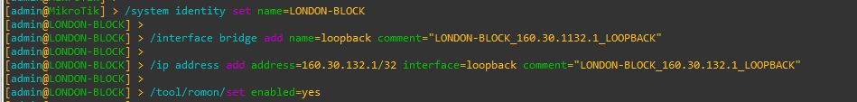

Figure 1: Set Identity, Loopback Address and RoMoN of LONDON_BLOCK Router Through CMD

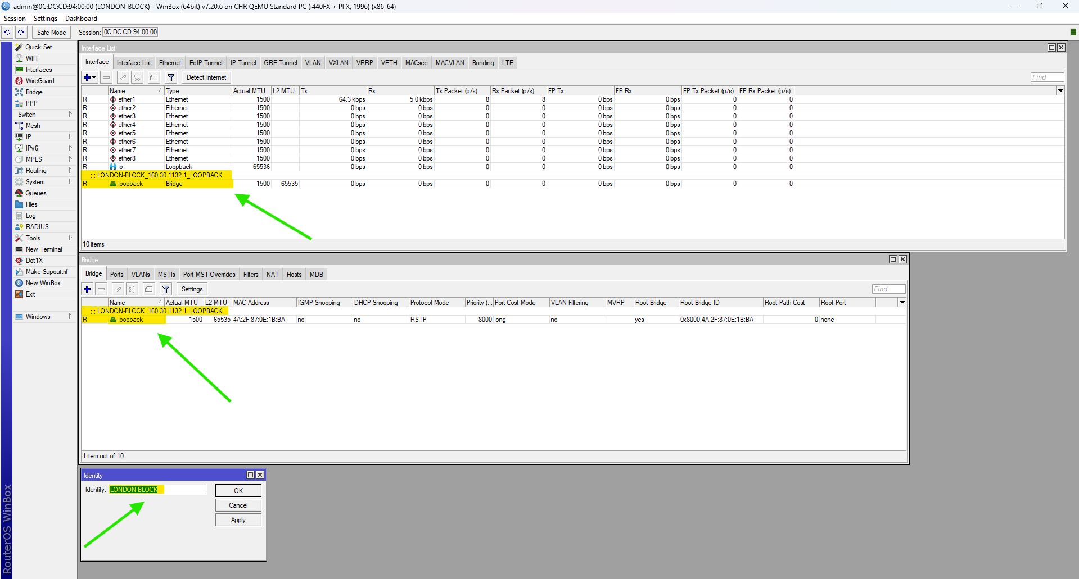

Figure 2: Set Identity, Loopback Address and RoMoN of LONDON_BLOCK Router Through WINBOX

## UK-BLOCK

**CMD**

|  |
| --- |
| /system identity set name= UK-BLOCK  /interface bridge add name=loopback comment=" UK-BLOCK_160.30.132.11_LOOPBACK"  /ip address add address=160.30.132.11/32 interface=loopback comment=" UK-BLOCK_160.30.132.11_LOOPBACK"  /tool/romon/set enabled=yes |

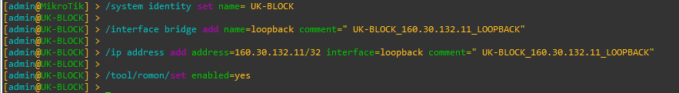

Figure 3: Set Identity, Loopback Address and RoMoN of UK-BLOCK Router Through CMD

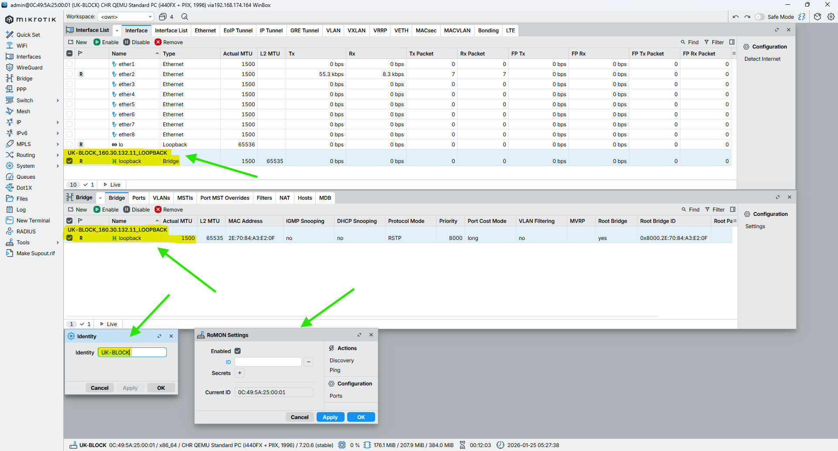

Figure 4: Set Identity, Loopback Address and RoMoN of UK-BLOCK Router Through WINBOX

## NEPAL-BLOCK

**CMD**

|  |
| --- |
| /system identity set name=NEPAL-BLOCK  /interface bridge add name=loopback comment="NEPAL-BLOCK_160.30.132.12_LOOPBACK"  /ip address add address=160.30.132.12/32 interface=loopback comment="NEPAL-BLOCK_160.30.132.12_LOOPBACK"  /tool/romon/set enabled=yes |

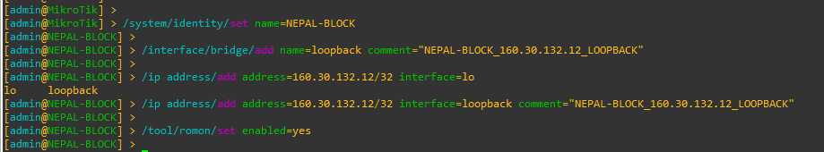

Figure 5: Set Identity, Loopback Address and RoMoN of NEPAL-BLOCK Router Through CMD

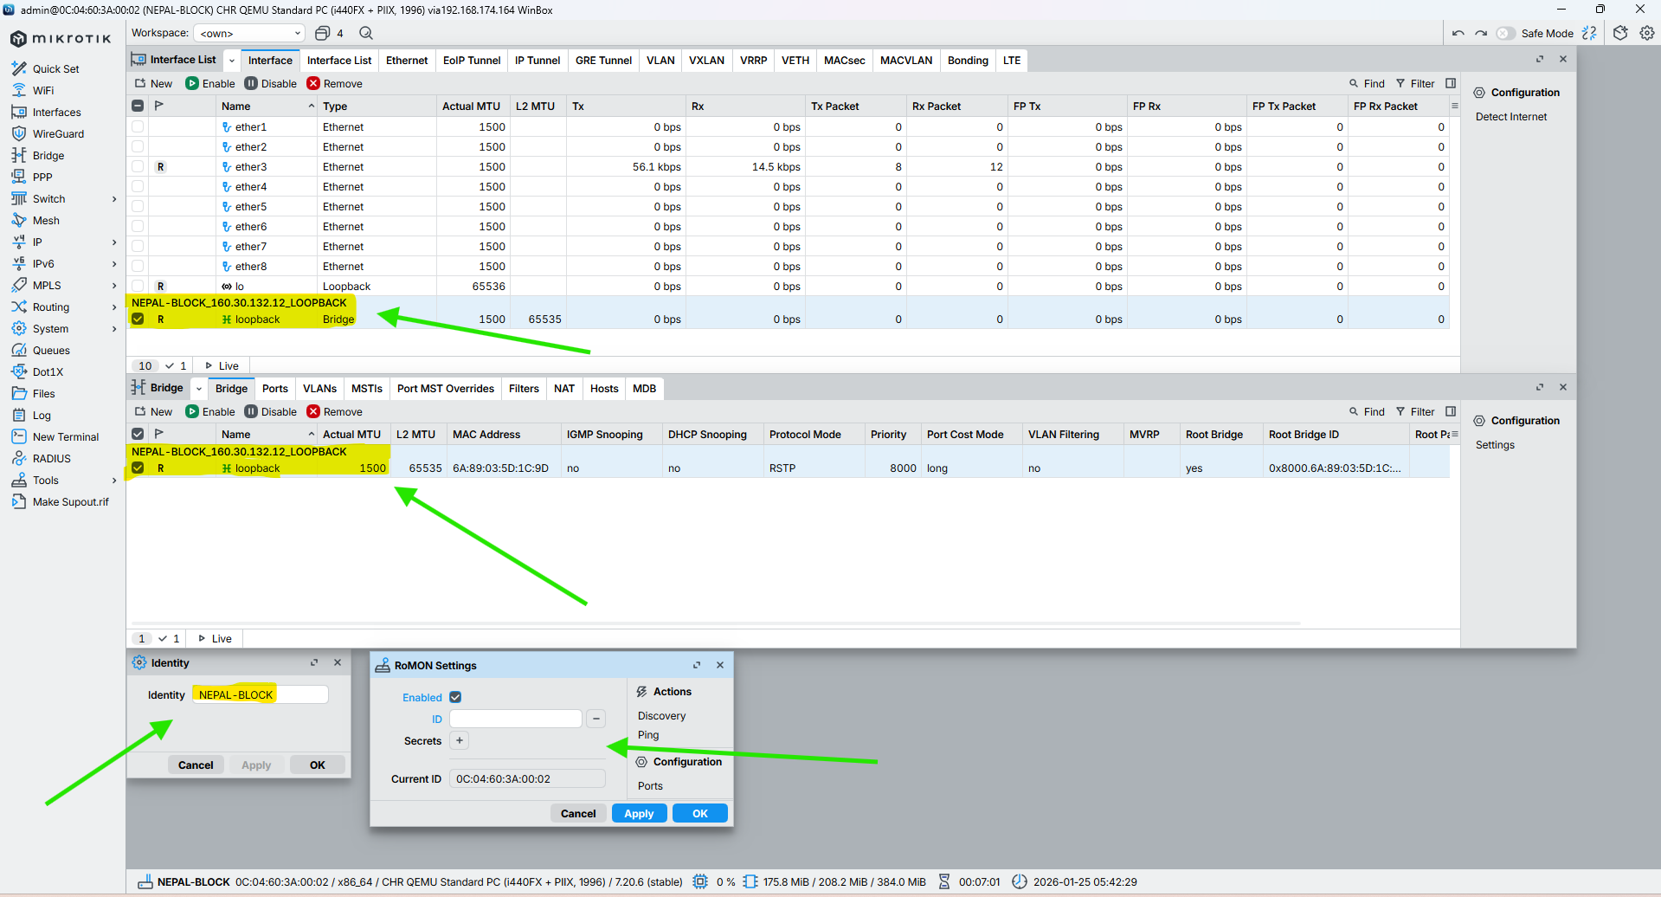

Figure 6: Set Identity, Loopback Address and RoMoN of NEPAL-BLOCK Router Through WINBOX

## HIMAL-BLOCK

**CMD**

|  |
| --- |
| /system identity set name=HIMAL-BLOCK  /interface bridge add name=loopback comment="HIMAL-BLOCK_160.30.132.13_LOOPBACK"  /ip address add address=160.30.132.13/32 interface=loopback comment="HIMAL-BLOCK_160.30.132.13_LOOPBACK"  /tool/romon/set enabled=yes |

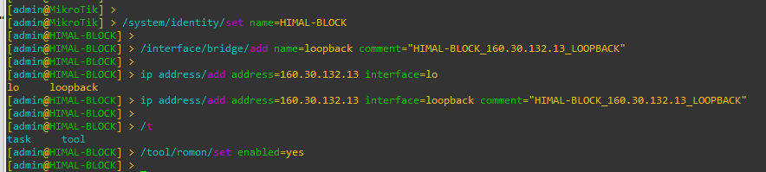

Figure 7: Set Identity, Loopback Address and RoMoN of NEPAL-BLOCK Router Through CMD

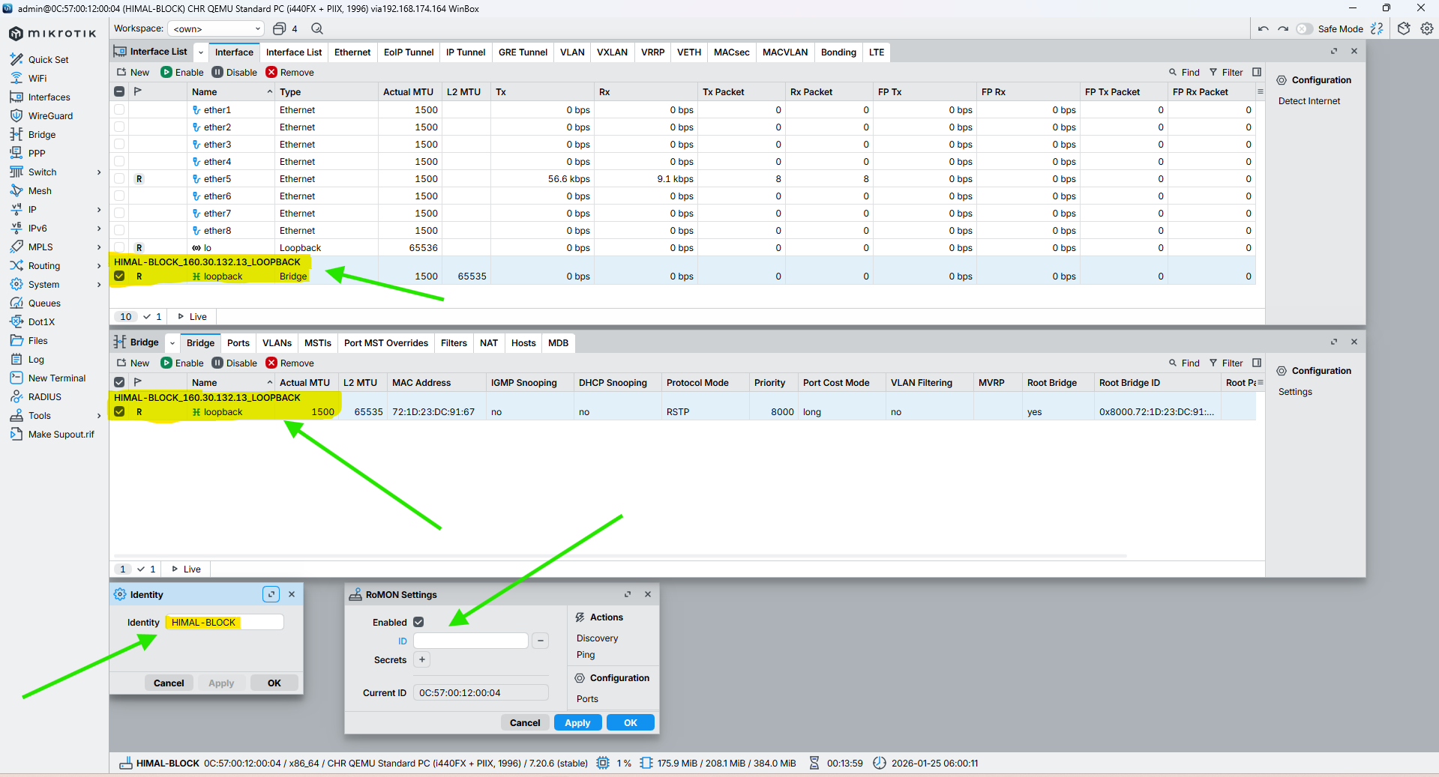

Figure 8: Set Identity, Loopback Address and RoMoN of NEPAL-BLOCK Router Through WINBOX

## BRIT-BLOCK

**CMD**

|  |
| --- |
| /system identity set name=BRIT-BLOCK  /interface bridge add name=loopback comment="BRIT-BLOCK_160.30.132.14_LOOPBACK"  /ip address add address=160.30.132.14/32 interface=loopback comment="BRIT-BLOCK_160.30.132.14_LOOPBACK"  /tool/romon/set enabled=yes |

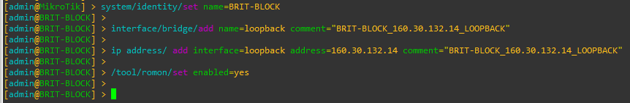

Figure 9: Set Identity, Loopback Address and RoMoN of BRIT-BLOCK Router Through CMD

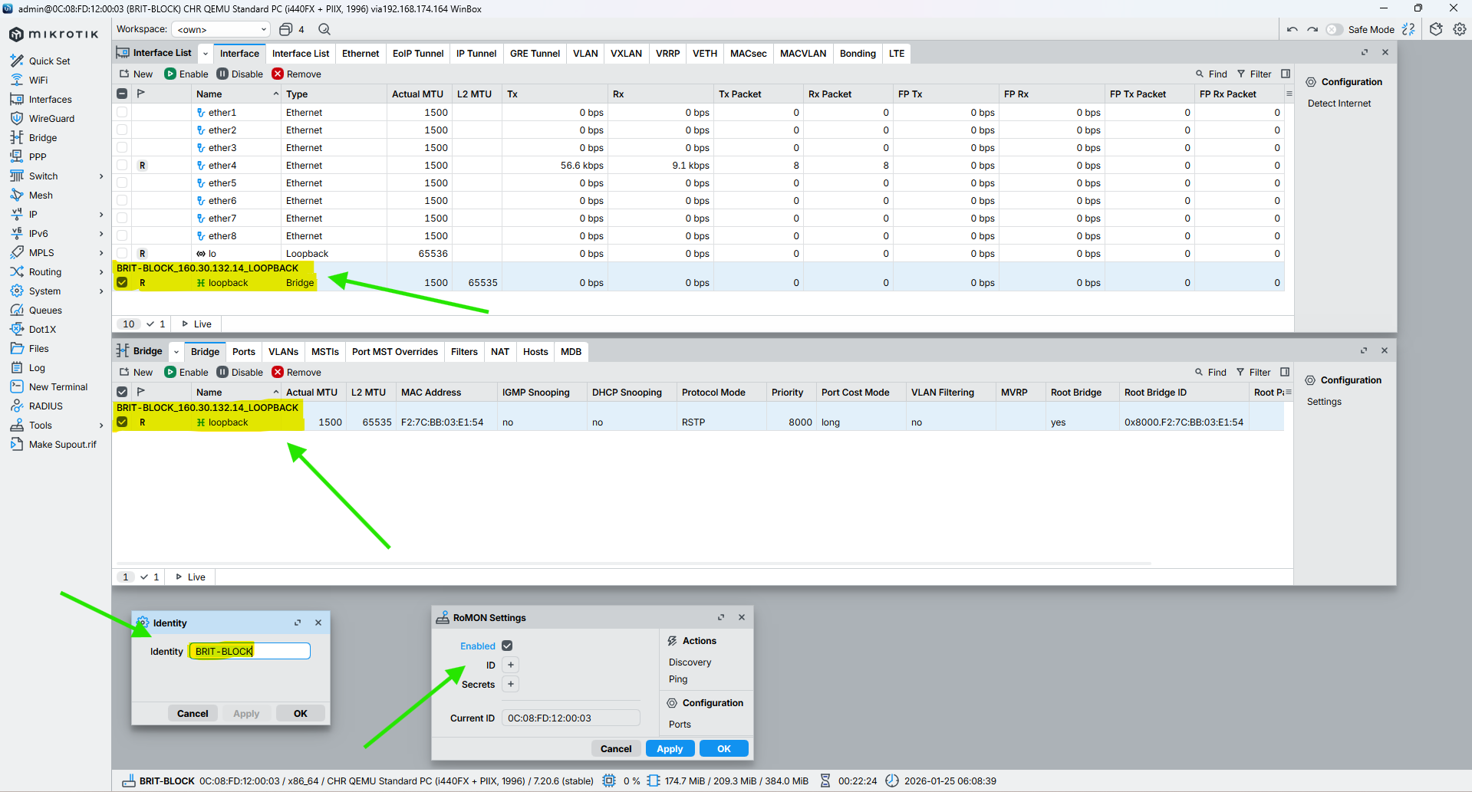

Figure 10: Set Identity, Loopback Address and RoMoN of BRIT-BLOCK Router Through WINBOX

## SKILL-BLOCK

**CMD**

|  |
| --- |
| /system identity set name=SKILL-BLOCK  /interface bridge add name=loopback comment="SKILL-BLOCK_160.30.132.15_LOOPBACK"  /ip address add address=160.30.132.15/32 interface=loopback comment="SKILL-BLOCK_160.30.132.15_LOOPBACK"  /tool/romon/set enabled=yes |

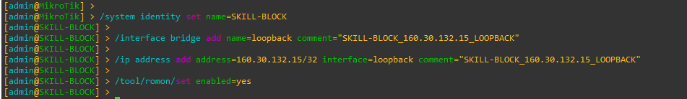

Figure 11: Set Identity, Loopback Address and RoMoN of SKILL-BLOCK Router Through CMD

Figure 12: Set Identity, Loopback Address and RoMoN of SKILL-BLOCK Router Through WINBOX

## ALUMNI-BLOCK

**CMD**

|  |
| --- |
| /system identity set name=ALUMNI-BLOCK  /interface bridge add name=loopback comment="ALUMNI-BLOCK_160.30.132.16_LOOPBACK"  /ip address add address=160.30.132.16/32 interface=loopback comment="ALUMNI-BLOCK_160.30.132.16_LOOPBACK"  /tool/romon/set enabled=yes |

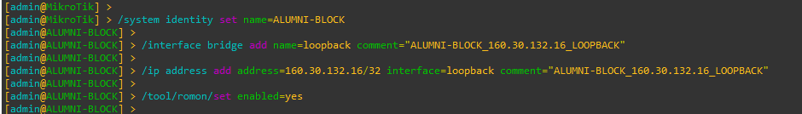

Figure 13: Set Identity, Loopback Address and RoMoN of ALUMNI-BLOCK Router Through CMD

Figure 14: Set Identity, Loopback Address and RoMoN of ALUMNI-BLOCK Router Through WINBOX

## KUMARI-BLOCK

**CMD**

|  |
| --- |
| /system identity set name=KUMARI-BLOCK  /interface bridge add name=loopback comment="KUMARI-BLOCK_160.30.132.17_LOOPBACK"  /ip address add address=160.30.132.17/32 interface=loopback comment="KUMARI-BLOCK_160.30.132.17_LOOPBACK"  /tool/romon/set enabled=yes |

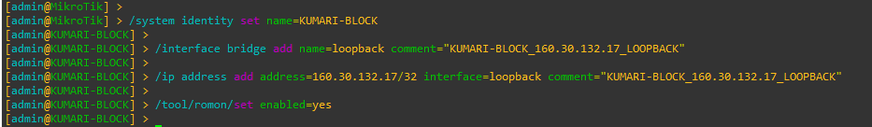

Figure 15: Set Identity, Loopback Address and RoMoN of KUMARI-BLOCK Router Through CMD

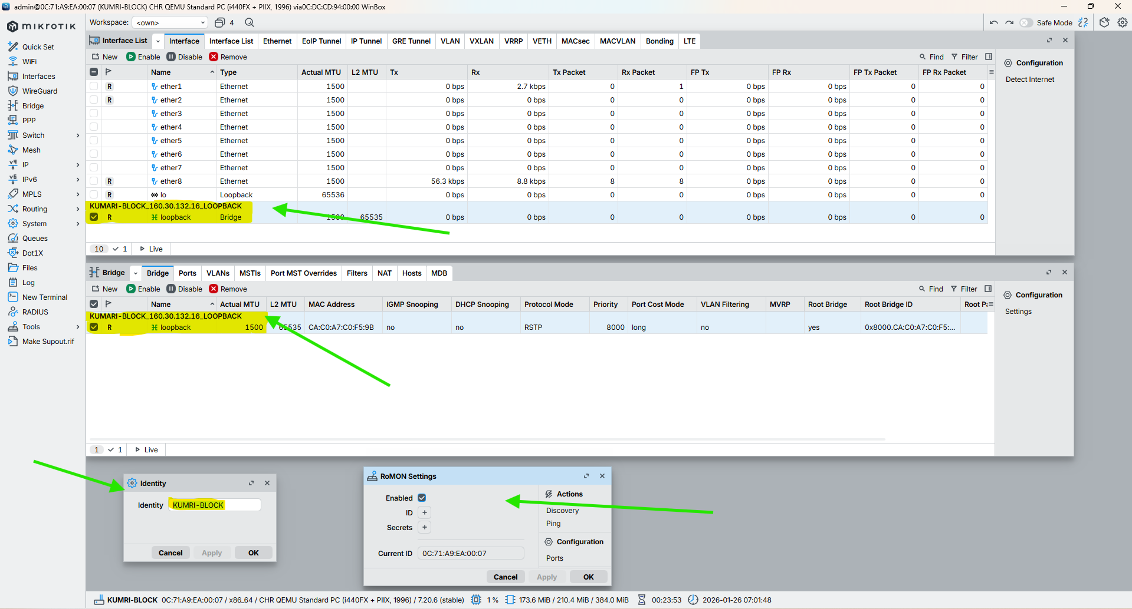

Figure 16: Set Identity, Loopback Address and RoMoN of KUMARI-BLOCK Router Through WINBOX

# Set description on the Interface to all router

## LONDON-BLOCK

CMD

|  |
| --- |
| /interface set ether2 comment="Link from LONDON-BLOCK (10.0.0.1/30) to UK-BLOCK (10.0.0.2/30)"  /interface set ether3 comment="Link from LONDON-BLOCK (10.0.0.5/30) to NEPAL-BLOCK (10.0.0.6/30)"  /interface set ether4 comment="Link from LONDON-BLOCK (10.0.0.9/30) to HIMAL-BLOCK (10.0.0.10/30)"  /interface set ether5 comment="Link from LONDON-BLOCK (10.0.0.13/30) to BRIT-BLOCK (10.0.0.14/30)"  /interface set ether6 comment="Link from LONDON-BLOCK (10.0.0.17/30) to SKILL-BLOCK (10.0.0.18/30)"  /interface set ether7 comment="Link from LONDON-BLOCK (10.0.0.21/30) to ALUMNI-BLOCK (10.0.0.22/30)"  /interface set ether8 comment="Link from LONDON-BLOCK (10.0.0.25/30) to KUMARI-BLOCK (10.0.0.26/30)"  /interface set ether9 comment="LAN / Management link from LONDON-BLOCK to Local Network (192.168.174.0/24)" |

## UK-BLOCK

CMD

|  |
| --- |
| /interface set ether2 comment="Link from UK-BLOCK (10.0.0.2/30) to LONDON-BLOCK (10.0.0.1/30)"  /interface set ether1 comment="Link from UK-BLOCK (10.0.0.29/30) to NEPAL-BLOCK (10.0.0.30/30)"  /interface set ether3 comment="Link from UK-BLOCK (10.0.0.34/30) to HIMAL-BLOCK (10.0.0.33/30)" |



## NEPAL-BLOCK

CMD

|  |
| --- |
| /interface set ether3 comment="Link from NEPAL-BLOCK (10.0.0.6/30) to LONDON-BLOCK (10.0.0.5/30)"  /interface set ether1 comment="Link from NEPAL-BLOCK (10.0.0.30/30) to UK-BLOCK (10.0.0.29/30)"  /interface set ether2 comment="Link from NEPAL-BLOCK (10.0.0.37/30) to BRIT-BLOCK (10.0.0.38/30)" |



## HIMAL-BLOCK

CMD

|  |
| --- |
| /interface set ether3 comment=”Link from HIMAL-BLOCK (10.0.0.33/30) to UK-BLOCK (10.0.0.34/30)”  /interface set ether4 comment=”Link from HIMAL-BLOCK (10.0.0.10/30) to LONDON-BLOCK (10.0.0.9/30)”  /interface set ether2 comment=”Link from HIMAL-BLOCK (10.0.0.42/30) to SKILL-BLOCK (10.0.0.41/30)” |



## BRIT-BLOCK

CMD

|  |
| --- |
| /interface set ether2 comment="Link from BRIT-BLOCK (10.0.0.38/30) to NEPAL-BLOCK (10.0.0.37/30)"  /interface set ether5 comment="Link from BRIT-BLOCK (10.0.0.14/30) to LONDON-BLOCK (10.0.0.13/30)"  /interface set ether1 comment="Link from BRIT-BLOCK (10.0.0.46/30) to KUMARI-BLOCK (10.0.0.44/30)" |



## SKILL-BLOCK

CMD

|  |
| --- |
| /interface set ether2 comment="Link from SKILL-BLOCK (10.0.0.41/30) to HIMAL-BLOCK (10.0.0.42/30)"  /interface set ether6 comment="Link from SKILL-BLOCK (10.0.0.18/30) to LONDON-BLOCK (10.0.0.17/30)"  /interface set ether1 comment="Link from SKILL-BLOCK (10.0.0.50/30) to KUMARI-BLOCK (10.0.0.49/30)" |



## ALUMNI-BLOCK

CMD

|  |
| --- |
| /interface set ether7 comment="Link from ALUMNI-BLOCK (10.0.0.22/30) to LONDON-BLOCK (10.0.0.21/30)"  /interface set ether1 comment="Link from ALUMNI-BLOCK (10.0.0.49/30) to SKILL-BLOCK (10.0.0.50/30)"  /interface set ether2 comment="Link from ALUMNI-BLOCK (10.0.0.53/30) to KUMARI-BLOCK (10.0.0.54/30)" |



## KUMARI-BLOCK

CMD

|  |
| --- |
| /interface set ether8 comment=”Link from KUMARI-BLOCK (10.0.0.26/30) to LONDON-BLOCK (10.0.0.25/30)”  /interface set ether2 comment=”Link from KUMARI-BLOCK (10.0.0.54/30) to ALUMNI-BLOCK (10.0.0.53/30)”  /interface set ether1 comment=”Link from KUMARI-BLOCK (10.0.0.44/30) to BRIT-BLOCK (10.0.0.46/30)” |



# Configuration IP in the Core Interface of all Routers

## LONDON-BLOCK

**CMD**

|  |
| --- |
| /ip address add address=10.0.0.1/30 interface=ether2 comment="NETWORK-ID_10.0.0.0/30_LINK_FROM_LONDON-BLOCK_10.0.0.1/30_TO_UK-BLOCK_10.0.0.2/30"  /ip address add address=10.0.0.5/30 interface=ether3 comment="NETWORK-ID_10.0.0.4/30_LINK_FROM_LONDON-BLOCK_10.0.0.5/30_TO_NEPAL-BLOCK_10.0.0.6/30"  /ip address add address=10.0.0.9/30 interface=ether4 comment="NETWORK-ID_10.0.0.8/30_LINK_FROM_LONDON-BLOCK_10.0.0.9/30_TO_HIMAL-BLOCK_10.0.0.10/30"  /ip address add address=10.0.0.13/30 interface=ether5 comment="NETWORK-ID_10.0.0.12/30_LINK_FROM_LONDON-BLOCK_10.0.0.13/30_TO_BRIT-BLOCK_10.0.0.14/30"  /ip address add address=10.0.0.17/30 interface=ether6 comment="NETWORK-ID_10.0.0.16/30_LINK_FROM_LONDON-BLOCK_10.0.0.17/30_TO_SKILL-BLOCK_10.0.0.18/30"  /ip address add address=10.0.0.21/30 interface=ether7 comment="NETWORK-ID_10.0.0.20/30_LINK_FROM_LONDON-BLOCK_10.0.0.21/30_TO_ALUMNI-BLOCK_10.0.0.22/30"  /ip address add address=10.0.0.25/30 interface=ether8 comment="NETWORK-ID_10.0.0.24/30_LINK_FROM_LONDON-BLOCK_10.0.0.25/30_TO_KUMARI-BLOCK_10.0.0.26/30" |

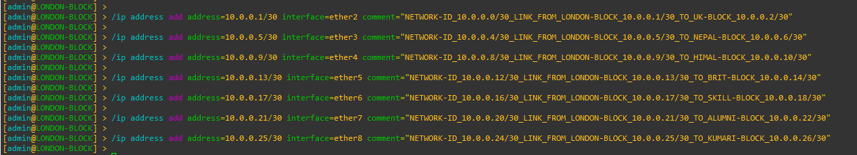

Figure 17: Configuration IP in the Core Interface of LONDON-BLOCK Router Through CMD

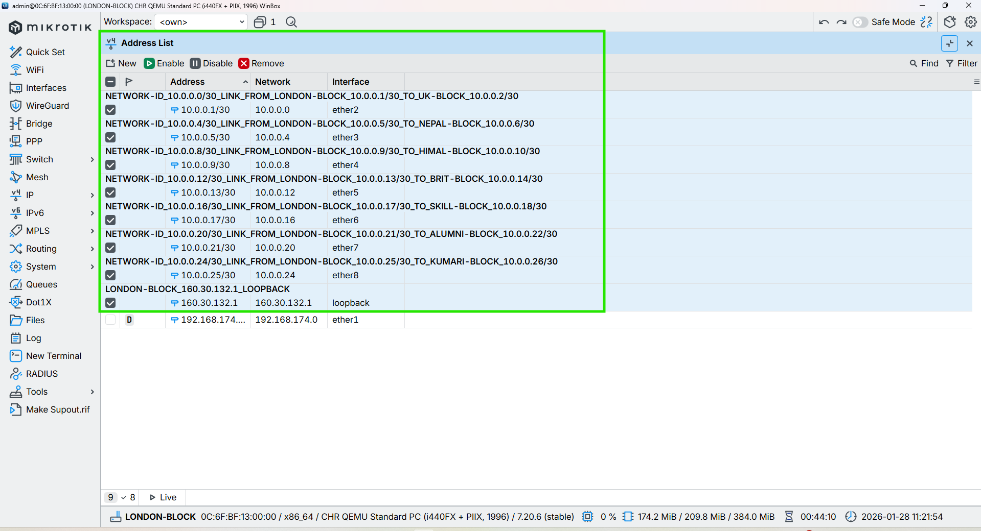

Figure 18: Configuration IP in the Core Interface of LONDON-BLOCK Router Through WINBOX

## UK-BLOCK

**CMD**

|  |
| --- |
| /ip address add address=10.0.0.2/30 interface=ether2 comment="NETWORK-ID_10.0.0.0/30_LINK_FROM_UK-BLOCK_10.0.0.2/30_TO_LONDON-BLOCK_10.0.0.1/30"  /ip address add address=10.0.0.29/30 interface=ether1 comment="NETWORK-ID_10.0.0.28/30_LINK_FROM_UK-BLOCK_10.0.0.29/30_TO_NEPAL-BLOCK_10.0.0.30/30"  /ip address add address=10.0.0.34/30 interface=ether3 comment="NETWORK-ID_10.0.0.32/30_LINK_FROM_UK-BLOCK_10.0.0.34/30_TO_HIMAL-BLOCK_10.0.0.33/30" |



Figure 19: Configuration IP in the Core Interface of UK-BLOCK Router Through CMD

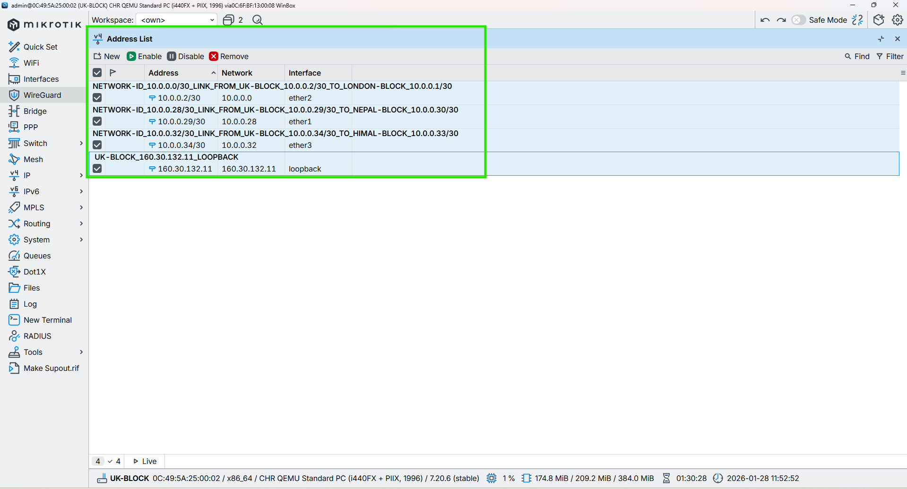

Figure 20: Configuration IP in the Core Interface of UK-BLOCK Router Through WINBOX

## NEPAL-BLOCK

**CMD**

|  |
| --- |
| /ip address add address=10.0.0.6/30 interface=ether3 comment="NETWORK-ID_10.0.0.4/30_LINK_FROM_NEPAL-BLOCK_10.0.0.6/30_TO_LONDON-BLOCK_10.0.0.5/30"  /ip address add address=10.0.0.30/30 interface=ether1 comment="NETWORK-ID_10.0.0.28/30_LINK_FROM_NEPAL-BLOCK_10.0.0.30/30_TO_UK-BLOCK_10.0.0.29/30"  /ip address add address=10.0.0.37/30 interface=ether2 comment="NETWORK-ID_10.0.0.36/30_LINK_FROM_NEPAL-BLOCK_10.0.0.37/30_TO_BRIT-BLOCK_10.0.0.38/30" |



Figure 21: Configuration IP in the Core Interface of NEPAL-BLOCK Router Through CMD

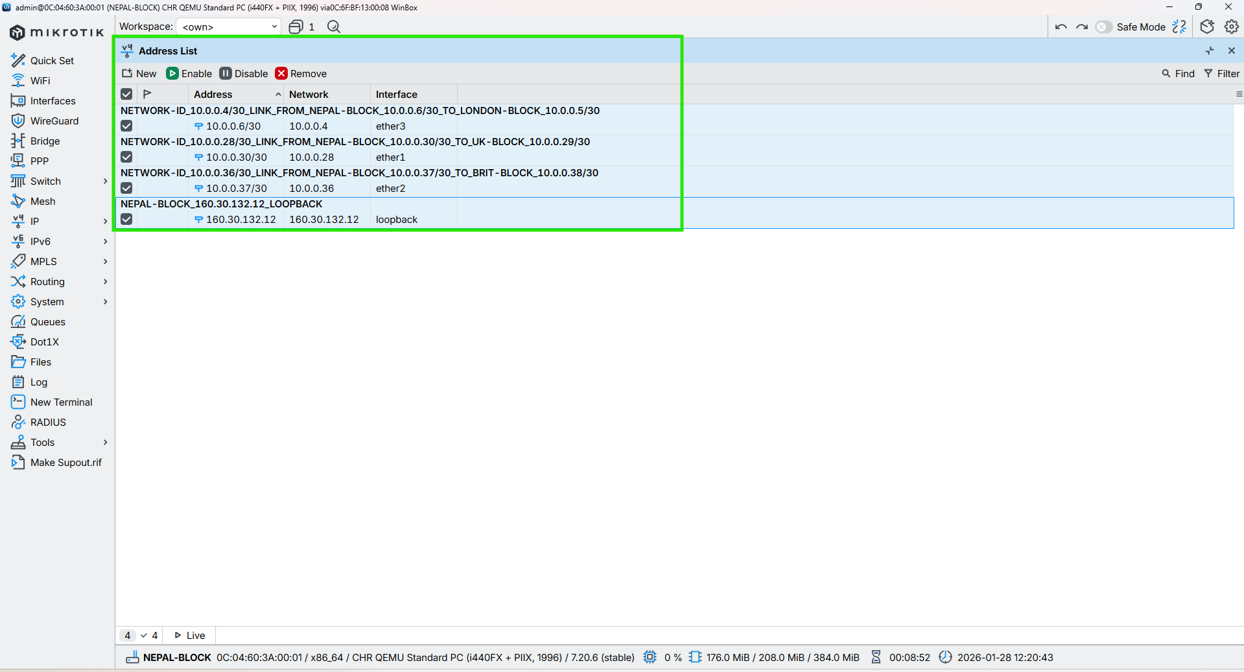

Figure 22: Configuration IP in the Core Interface of NEPAL-BLOCK Router Through WINBOX

## HIMAL-BLOCK

**CMD**

|  |
| --- |
| /ip address add address=10.0.0.33/30 interface=ether3 comment="NETWORK-ID_10.0.0.32/30_LINK_FROM_HIMAL-BLOCK_10.0.0.33/30_TO_UK-BLOCK_10.0.0.34/30"  /ip address add address=10.0.0.10/30 interface=ether4 comment="NETWORK-ID_10.0.0.8/30_LINK_FROM_HIMAL-BLOCK_10.0.0.10/30_TO_LONDON-BLOCK_10.0.0.9/30"  /ip address add address=10.0.0.42/30 interface=ether2 comment="NETWORK-ID_10.0.0.40/30_LINK_FROM_HIMAL-BLOCK_10.0.0.42/30_TO_SKILL-BLOCK_10.0.0.41/30"c |



Figure 23: Configuration IP in the Core Interface of HIMAL-BLOCK Router Through CMD

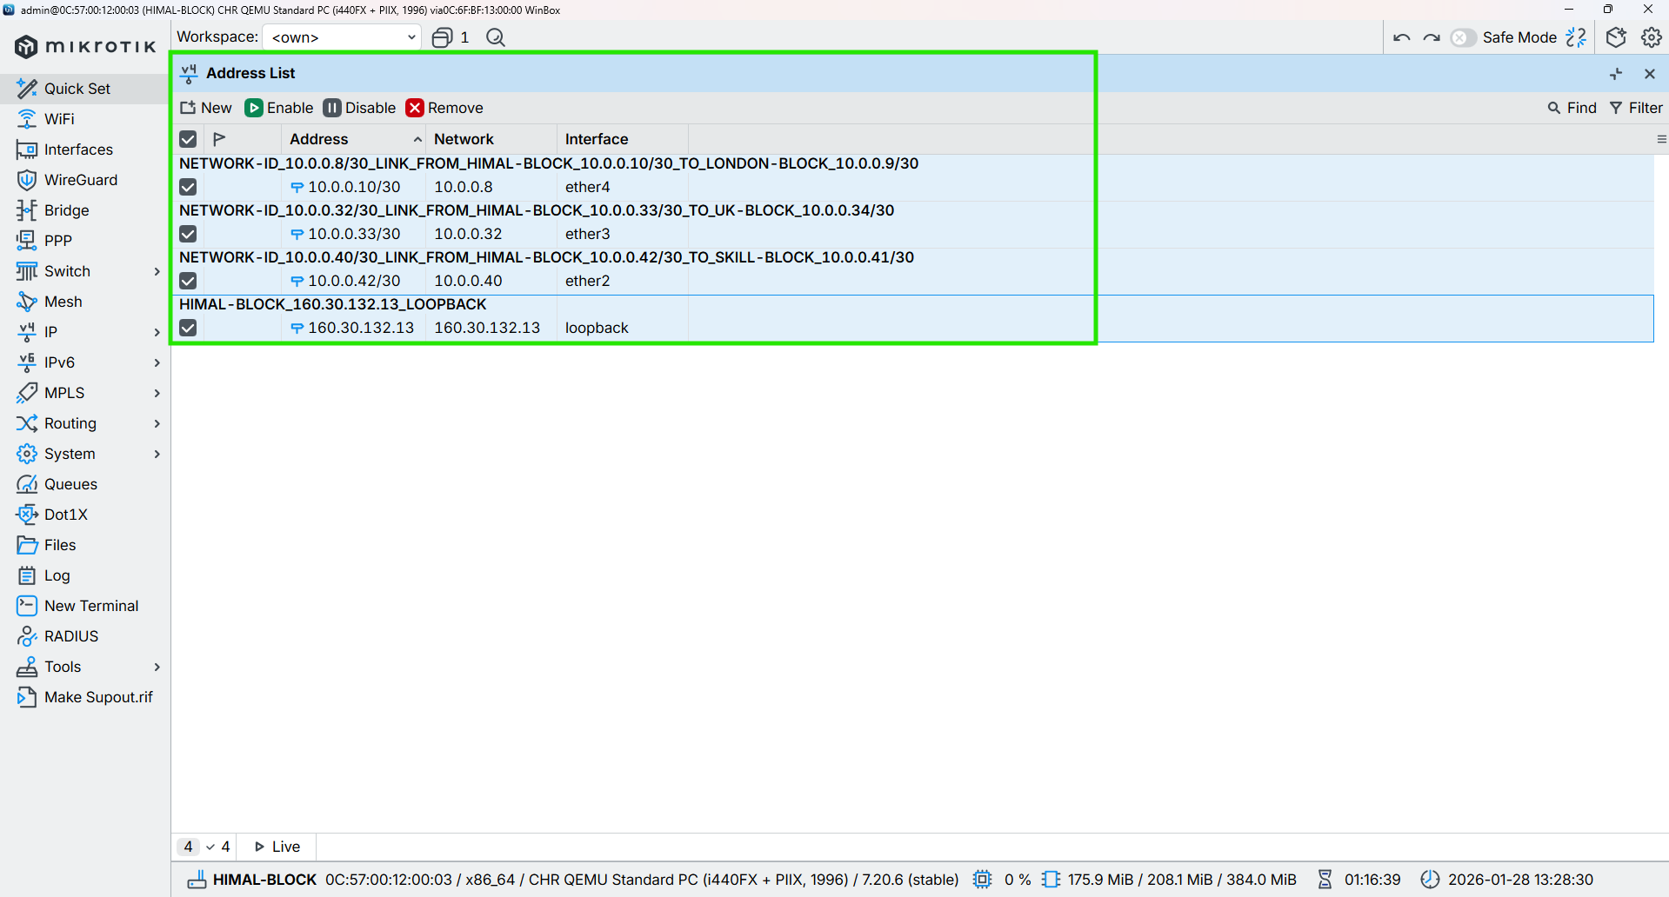

Figure 24: Configuration IP in the Core Interface of HIMAL-BLOCK Router Through WINBOX

## BRIT-BLOCK

**CMD**

|  |
| --- |
| /ip address add address=10.0.0.38/30 interface=ether2 comment="NETWORK-ID_10.0.0.36/30_LINK_FROM_BRIT-BLOCK_10.0.0.38/30_TO_NEPAL-BLOCK_10.0.0.37/30"  /ip address add address=10.0.0.14/30 interface=ether5 comment="NETWORK-ID_10.0.0.12/30_LINK_FROM_BRIT-BLOCK_10.0.0.14/30_TO_LONDON-BLOCK_10.0.0.13/30"  /ip address add address=10.0.0.46/30 interface=ether1 comment="NETWORK-ID_10.0.0.44/30_LINK_FROM_BRIT-BLOCK_10.0.0.46/30_TO_KUMARI-BLOCK_10.0.0.45/30" |



Figure 25: Configuration IP in the Core Interface of BRIT-BLOCK Router Through CMD

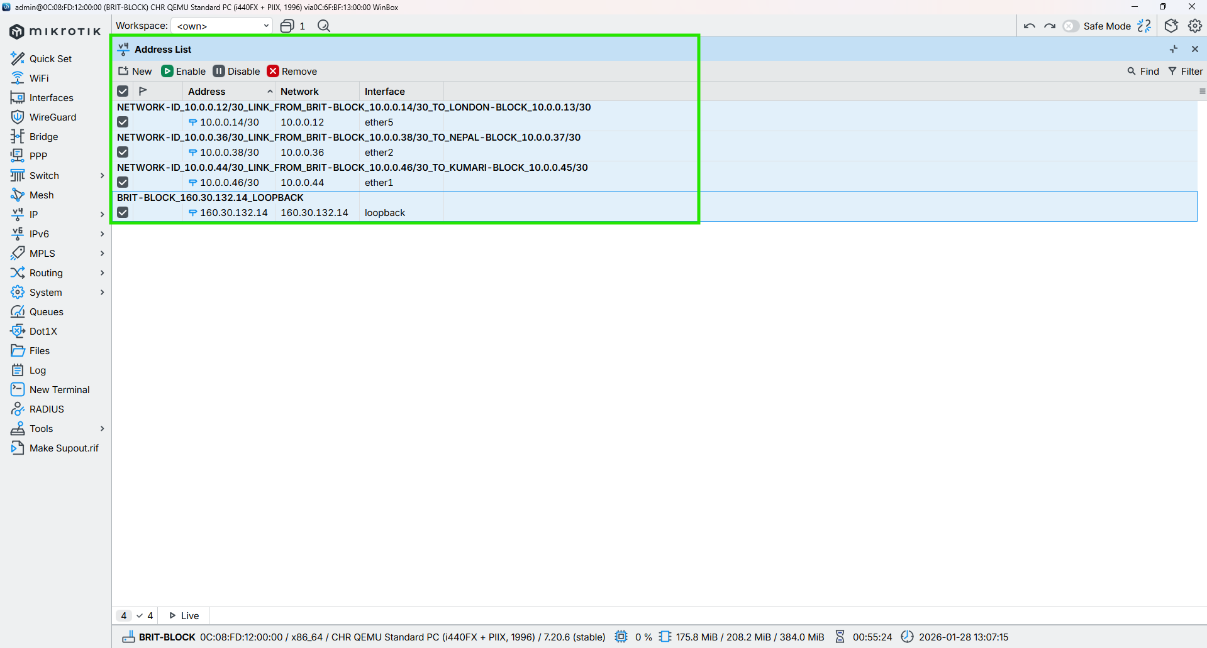

Figure 26: Configuration IP in the Core Interface of BRIT-BLOCK Router Through WINBOX

## SKILL-BLOCK

**CMD**

|  |
| --- |
| /ip address add address=10.0.0.41/30 interface=ether2 comment=”NETWORK-ID_10.0.0.40/30_LINK_FROM_SKILL-BLOCK_10.0.0.41/30_TO_NEPAL-BLOCK_10.0.0.42/30”  /ip address add address=10.0.0.18/30 interface=ether6 comment=”NETWORK-ID_10.0.0.16/30_LINK_FROM_SKILL-BLOCK_10.0.0.18/30_TO_LONDON-BLOCK_10.0.0.17/30”  /ip address add address=10.0.0.50/30 interface=ether1 comment=”NETWORK-ID_10.0.0.48/30_LINK_FROM_SKILL-BLOCK_10.0.0.50/30_TO_KUMARI-BLOCK_10.0.0.49/30” |



Figure 27: Configuration IP in the Core Interface of SKILL-BLOCK Router Through CMD

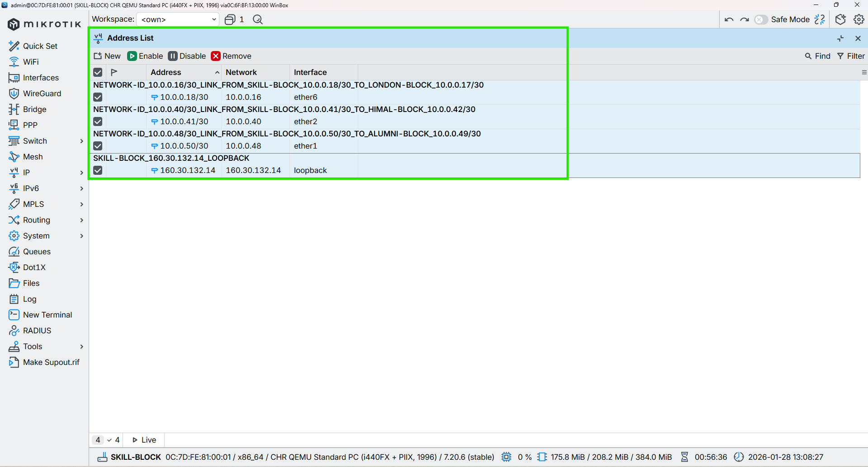

Figure 28: Configuration IP in the Core Interface of SKILL-BLOCK Router Through WINBOX

## ALUMNI-BLOCK

**CMD**

|  |
| --- |
| /ip address add address=10.0.0.22/30 interface=ether7 comment="NETWORK-ID_10.0.0.20/30_LINK_FROM_ALUMNI-BLOCK_10.0.0.22/30_TO_LONDON-BLOCK_10.0.0.21/30"  /ip address add address=10.0.0.49/30 interface=ether1 comment="NETWORK-ID_10.0.0.48/30_LINK_FROM_ALUMNI-BLOCK_10.0.0.49/30_TO_SKILL-BLOCK_10.0.0.50/30"  /ip address add address=10.0.0.53/30 interface=ether2 comment="NETWORK-ID_10.0.0.52/30_LINK_FROM_ALUMNI-BLOCK_10.0.0.53/30_TO_KUMARI-BLOCK_10.0.0.54/30" |

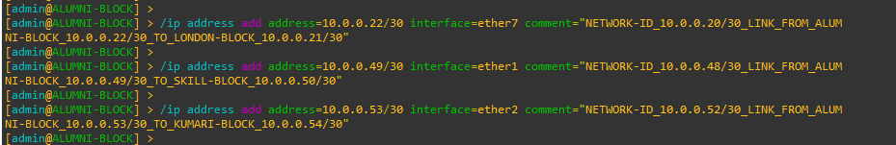

Figure 29: Configuration IP in the Core Interface of ALUMNI-BLOCK Router Through CMD

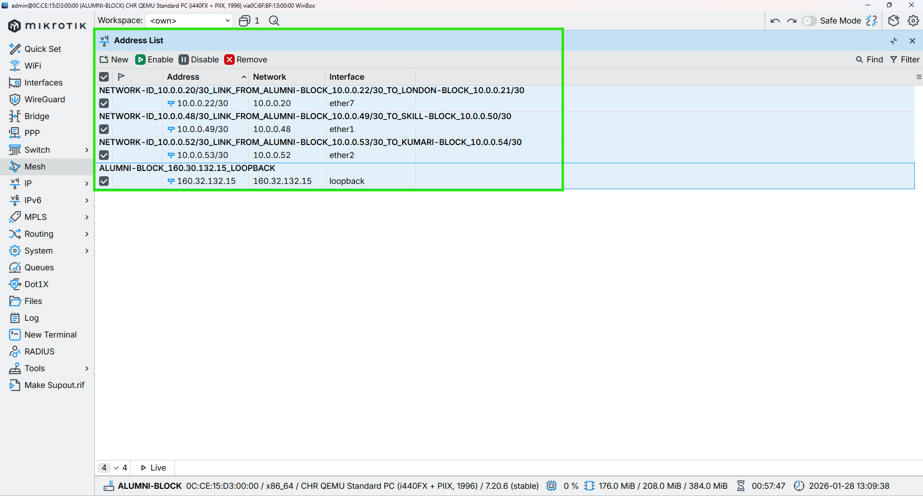

Figure 30: Configuration IP in the Core Interface of ALUMNI-BLOCK Router Through WINBOX

## KUMARI-BLOCK

**CMD**

|  |
| --- |
| /ip address add address=10.0.0.26/30 interface=ether8 comment="NETWORK-ID_10.0.0.24/30_LINK_FROM_KUMARI-BLOCK_10.0.0.26/30_TO_LONDON-BLOCK_10.0.0.25/30"  /ip address add address=10.0.0.54/30 interface=ether2 comment="NETWORK-ID_10.0.0.52/30_LINK_FROM_KUMARI-BLOCK_10.0.0.54/30_TO_ALUMNI-BLOCK_10.0.0.53/30"  /ip address add address=10.0.0.44/30 interface=ether1 comment="NETWORK-ID_10.0.0.44/30_LINK_FROM_KUMARI-BLOCK_10.0.0.44/30_TO_BRIT-BLOCK_10.0.0.46/30" |



Figure 31: Configuration IP in the Core Interface of KUMARI-BLOCK Router Through CMD

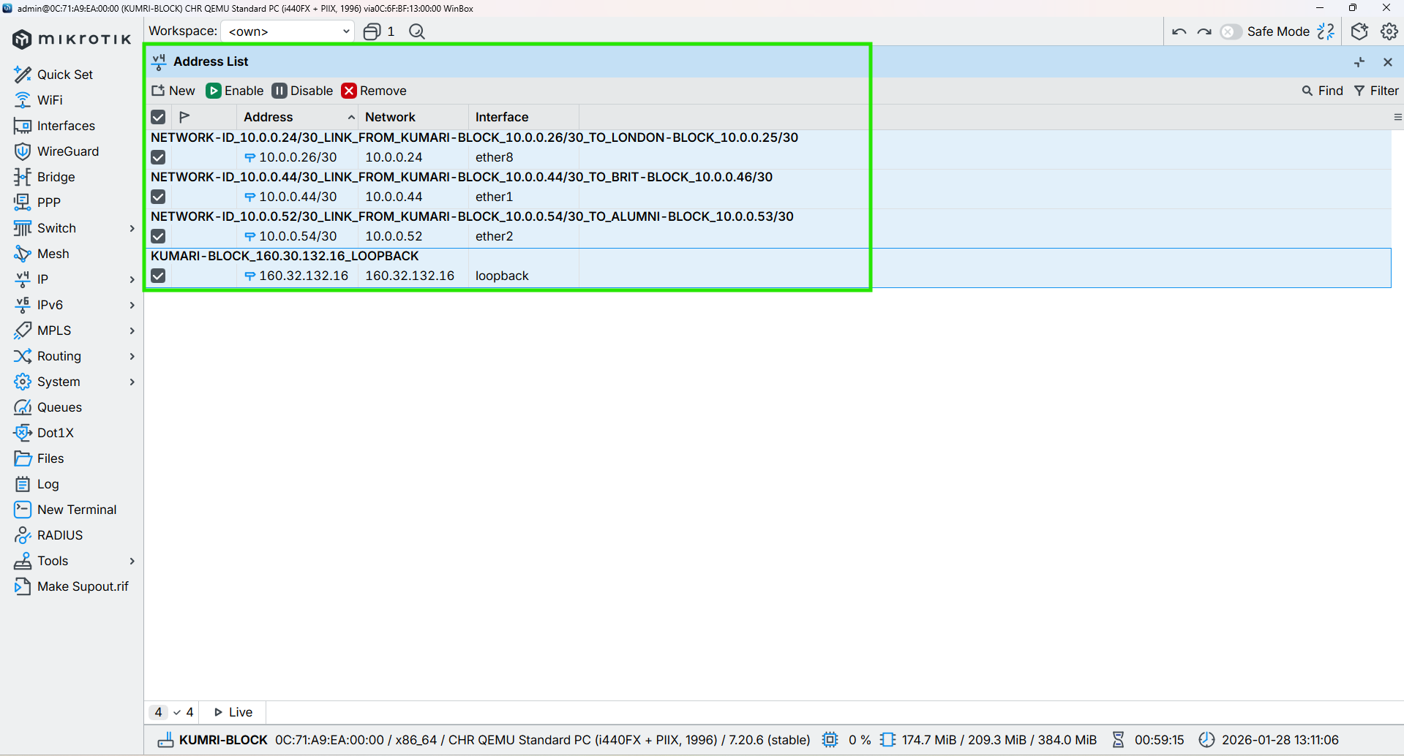

Figure 32: Configuration IP in the Core Interface of KUMARI-BLOCK Router Through WINBOX

# Configuration OSPF to all Core Routers

## LONDON-BLOCK

CMD

|  |
| --- |
| /routing ospf instance add name=OSPF_LONDON_BLOCK router-id=160.30.132.1 comment="OSPF instance for London block, router-id 160.30.132.1"  /routing ospf area add name=backbone area-id=0.0.0.0 instance=OSPF_LONDON_BLOCK comment="Backbone area 0.0.0.0 for London OSPF"  /routing ospf interface-template  add interfaces=loopback area=backbone passive comment="Loopback London router-id 160.30.132.1 (passive)"  add networks=10.0.0.0/30 interfaces=ether2 area=backbone comment="ETHER-2_LINK_FROM_LONDON-BLOCK_10.0.0.1_TO_UK-BLOCK_10.0.0.2"  add networks=10.0.0.4/30 interfaces=ether3 area=backbone comment="ETHER-3_LINK_FROM_LONDON-BLOCK_10.0.0.5_TO_NEPAL-BLOCK_10.0.0.6"  add networks=10.0.0.8/30 interfaces=ether4 area=backbone comment="ETHER-4_LINK_FROM_LONDON-BLOCK_10.0.0.9_TO_HIMAL-BLOCK_10.0.0.10"  add networks=10.0.0.12/30 interfaces=ether5 area=backbone comment="ETHER-5_LINK_FROM_LONDON-BLOCK_10.0.0.13_TO_BRIT-BLOCK_10.0.0.14"  add networks=10.0.0.16/30 interfaces=ether6 area=backbone comment="ETHER-6_LINK_FROM_LONDON-BLOCK_10.0.0.17_TO_SKILL-BLOCK_10.0.0.18"  add networks=10.0.0.20/30 interfaces=ether7 area=backbone comment="ETHER-7_LINK_FROM_LONDON-BLOCK_10.0.0.21_TO_ALUMNI-BLOCK_10.0.0.22"  add networks=10.0.0.24/30 interfaces=ether8 area=backbone comment="ETHER-8_LINK_FROM_LONDON-BLOCK_10.0.0.25_TO_KUMARI-BLOCK_10.0.0.26" |

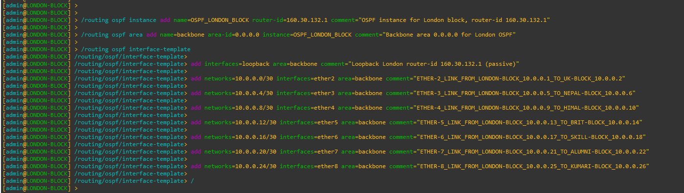

Figure 33: Configuration OSPF to Core LONDON-BLOCK Router Through CMD

|  |
| --- |
| Figure 34: Configuration OSPF Instances to Core LONDON-BLOCK Router Through WINBOX |
| Figure 35: Configuration OSPF Area to Core LONDON-BLOCK Router Through WINBOX |
| Figure 36: Configuration OSPF Interface-template to Core LONDON-BLOCK Router Through WINBOX |

## UK-BLOCK

CMD

|  |
| --- |
| /routing ospf instance add name=OSPF_UK_BLOCK router-id=160.30.132.11 comment="OSPF instance for UK block, router-id 160.30.132.11"  /routing ospf area add name=backbone area-id=0.0.0.0 instance=OSPF_UK_BLOCK comment="Backbone area 0.0.0.0 for UK OSPF"  /routing ospf interface-template  add interfaces=loopback area=backbone comment="Loopback UK router-id 160.30.132.11 (passive)"  add networks=10.0.0.0/30 interfaces=ether2 area=backbone comment="ETHER-2_LINK_FROM_UK-BLOCK_10.0.0.2_TO_LONDON-BLOCK_10.0.0.1"  add networks=10.0.0.28/30 interfaces=ether1 area=backbone comment="ETHER-3_LINK_FROM_UK-BLOCK_10.0.0.29_TO_NEPAL-BLOCK_10.0.0.30"  add networks=10.0.0.32/30 interfaces=ether3 area=backbone comment="ETHER-3_LINK_FROM_UK-BLOCK_10.0.0.34_TO_HIMAL-BLOCK_10.0.0.33" |

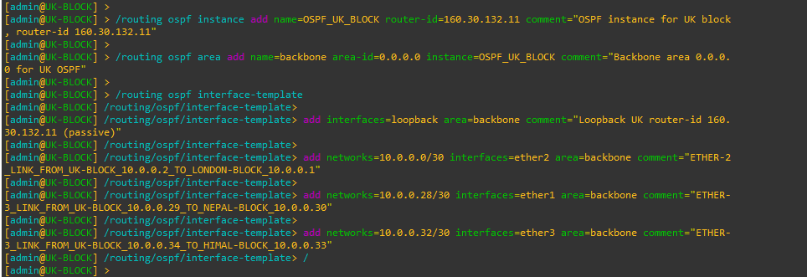

Figure 37: Configuration OSPF to UK-BLOCK Router Through CMD

|  |
| --- |
| Figure 38: Configuration OSPF Instances to UK-BLOCK Router Through WINBOX |
| Figure 39: Configuration OSPF Area to UK-BLOCK Router Through WINBOX |
| Figure 40: Configuration OSPF Interface-template to UK-BLOCK Router Through WINBOX |

## NEPAL-BLOCK

**CMD**

|  |
| --- |
| /routing ospf instance add name=OSPF_NEPAL_BLOCK router-id=160.30.132.12 comment="OSPF instance for NEPAL block, router-id 160.30.132.12"  /routing ospf area add name=backbone area-id=0.0.0.0 instance=OSPF_NEPAL_BLOCK comment="Backbone area 0.0.0.0 for NEPAL OSPF"  /routing ospf interface-template  add interfaces=loopback area=backbone comment="Loopback NEPAL router-id 160.30.132.12 (passive)"  add networks=10.0.0.28/30 interfaces=ether1 area=backbone comment="ETHER-1_LINK_FROM_NEPAL-BLOCK_10.0.0.30_TO_UK-BLOCK_10.0.0.29"  add networks=10.0.0.4/30 interfaces=ether3 area=backbone comment="ETHER-3_LINK_FROM_NEPAL-BLOCK_10.0.0.6_TO_LONDON-BLOCK_10.0.0.5"  add networks=10.0.0.36/30 interfaces=ether2 area=backbone comment="ETHER-2_LINK_FROM_NEPAL-BLOCK_10.0.0.37_TO_BRIT-BLOCK_10.0.0.38" |

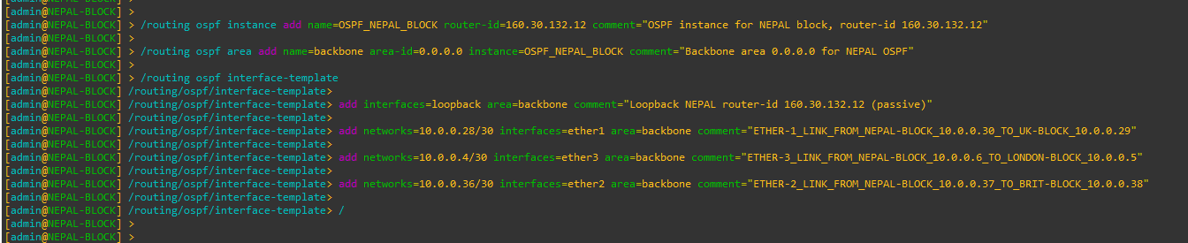

Figure 41: Configuration OSPF to NEPAL-BLOCK Router Through CMD

|  |
| --- |
| Figure 42: Configuration OSPF Instances to NEPAL-BLOCK Router Through WINBOX |
| Figure 43: Configuration OSPF Area to NEPAL-BLOCK Router Through WINBOX |
| Figure 44: Configuration OSPF Interface-template to NEPAL-BLOCK Router Through WINBOX |

## HIMAL-BLOCK

CMD

|  |
| --- |
| /routing ospf instance add name=OSPF_HIMAL_BLOCK router-id=160.30.132.13 comment="OSPF instance for HIMAL block, router-id 160.30.132.13"  /routing ospf area add name=backbone area-id=0.0.0.0 instance=OSPF_HIMAL_BLOCK comment="Backbone area 0.0.0.0 for HIMAL OSPF"  /routing ospf interface-template  add interfaces=loopback area=backbone comment="Loopback HIMAL router-id 160.30.132.13 (passive)"  add networks=10.0.0.32/30 interfaces=ether3 area=backbone comment="ETHER-3_LINK_FROM_HIMAL-BLOCK_10.0.0.33_TO_UK-BLOCK_10.0.0.34"  add networks=10.0.0.8/30 interfaces=ether4 area=backbone comment="ETHER-4_LINK_FROM_HIMAL-BLOCK_10.0.0.10_TO_LONDON-BLOCK_10.0.0.9"  add networks=10.0.0.40/30 interfaces=ether2 area=backbone comment="ETHER-2_LINK_FROM_HIMAL-BLOCK_10.0.0.42_TO_SKILL-BLOCK_10.0.0.41" |

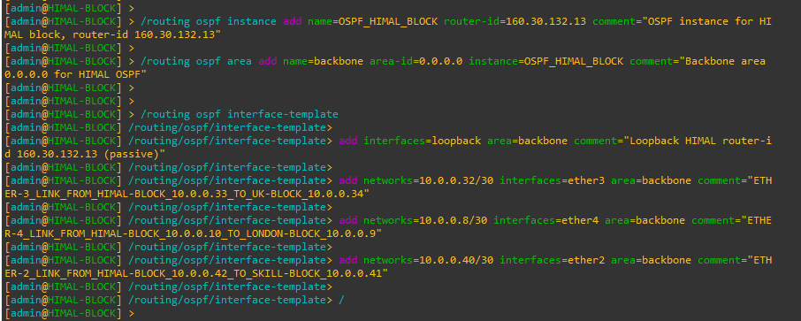

Figure 45: Configuration OSPF to HIMAL-BLOCK Router Through CMD

|  |
| --- |
| Figure 46: Configuration OSPF Instances to HIMAL-BLOCK Router Through WINBOX |
| Figure 47: Configuration OSPF Area to HIMAL-BLOCK Router Through WINBOX |
| Figure 48: Configuration OSPF Interface-template to HIMAL-BLOCK Router Through WINBOX |

## BRIT-BLOCK

**CMD**

|  |
| --- |
| /routing ospf instance add name=OSPF_BRIT_BLOCK router-id=160.30.132.14 comment="OSPF instance for BRIT block, router-id 160.30.132.14"  /routing ospf area add name=backbone area-id=0.0.0.0 instance=OSPF_BRIT_BLOCK comment="Backbone area 0.0.0.0 for BRIT OSPF"  /routing ospf interface-template  add interfaces=loopback area=backbone comment="Loopback BRIT router-id 160.30.132.14 (passive)"  add networks=10.0.0.36/30 interfaces=ether2 area=backbone comment="ETHER-2_LINK_FROM_BRIT-BLOCK_10.0.0.38_TO_NEPAL-BLOCK_10.0.0.37"  add networks=10.0.0.12/30 interfaces=ether5 area=backbone comment="ETHER-5_LINK_FROM_BRIT-BLOCK_10.0.0.14_TO_LONDON-BLOCK_10.0.0.13"  add networks=10.0.0.44/30 interfaces=ether1 area=backbone comment="ETHER-1_LINK_FROM_BRIT-BLOCK_10.0.0.46_TO_SKILL-BLOCK_10.0.0.45" |

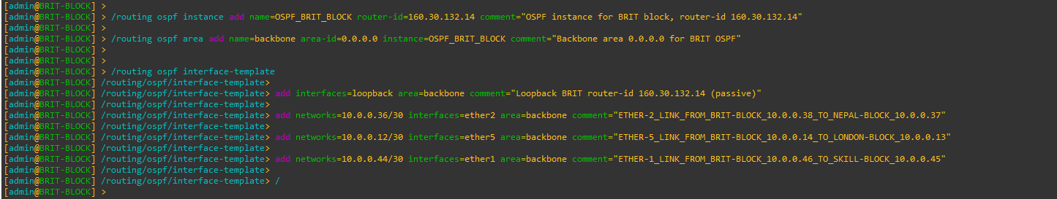

Figure 49: Configuration OSPF to BRIT-BLOCK Router Through CMD

|  |
| --- |
| Figure 50: Configuration OSPF Instances to BRIT-BLOCK Router Through WINBOX |
| Figure 51: Configuration OSPF Area to BRIT-BLOCK Router Through WINBOX |
| Figure 52: Configuration OSPF Interface-template to BRIT-BLOCK Router Through WINBOX |

## SKILL-BLOCK

CMD

|  |
| --- |
| /routing ospf instance add name=OSPF_SKILL_BLOCK router-id=160.30.132.15 comment="OSPF instance for SKILL block, router-id 160.30.132.15"  /routing ospf area add name=backbone area-id=0.0.0.0 instance=OSPF_SKILL_BLOCK comment="Backbone area 0.0.0.0 for SKILL OSPF"  /routing ospf interface-template  add interfaces=loopback area=backbone comment="Loopback SKILL router-id 160.30.132.15 (passive)"  add networks=10.0.0.40/30 interfaces=ether2 area=backbone comment="ETHER-2_LINK_FROM_SKILL-BLOCK_10.0.0.41_TO_HIMAL-BLOCK_10.0.0.42"  add networks=10.0.0.16/30 interfaces=ether6 area=backbone comment="ETHER-6_LINK_FROM_SKILL-BLOCK_10.0.0.18_TO_LONDON-BLOCK_10.0.0.17"  add networks=10.0.0.48/30 interfaces=ether1 area=backbone comment="ETHER-1_LINK_FROM_SKILL-BLOCK_10.0.0.50_TO_ALUMNI-BLOCK_10.0.0.49" |

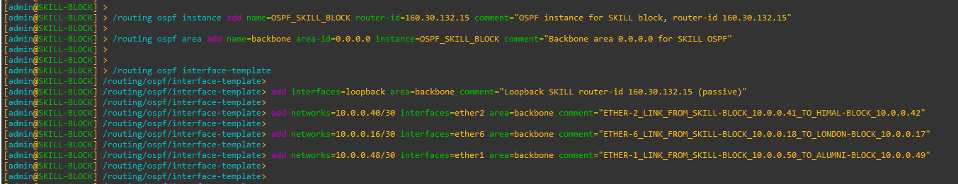

Figure 53: Configuration OSPF to SKILL-BLOCK Router Through CMD

|  |
| --- |
| Figure 54: Configuration OSPF Instances to SKILL-BLOCK Router Through WINBOX |
| Figure 55: Configuration OSPF Area to SKILL-BLOCK Router Through WINBOX |
| Figure 56: Configuration OSPF Interface-template to SKILL-BLOCK Router Through WINBOX |

## ALUMNI-BLOCK

CMD

|  |
| --- |
| /routing ospf instance add name=OSPF_ALUMNI_BLOCK router-id=160.30.132.16 comment="OSPF instance for ALUMNI block, router-id 160.30.132.16"  /routing ospf area add name=backbone area-id=0.0.0.0 instance=OSPF_ALUMNI_BLOCK comment="Backbone area 0.0.0.0 for ALUMNI OSPF"  /routing ospf interface-template  add interfaces=loopback area=backbone comment="Loopback ALUMNI router-id 160.30.132.16 (passive)"  add networks=10.0.0.48/30 interfaces=ether1 area=backbone comment="ETHER-1_LINK_FROM_ALUMNI-BLOCK_10.0.0.49_TO_SKILL-BLOCK_10.0.0.50"  add networks=10.0.0.20/30 interfaces=ether7 area=backbone comment="ETHER-7_LINK_FROM_ALUMNI-BLOCK_10.0.0.22_TO_LONDON-BLOCK_10.0.0.21"  add networks=10.0.0.52/30 interfaces=ether2 area=backbone comment="ETHER-2_LINK_FROM_ALUMNI-BLOCK_10.0.0.53_TO_KUMARI-BLOCK_10.0.0.54" |

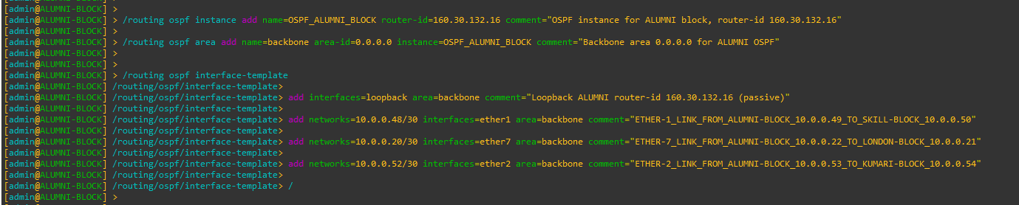

Figure 57: Configuration OSPF to ALUMNI-BLOCK Router Through CMD

|  |
| --- |
| Figure 58: Configuration OSPF Instances to ALUMNI-BLOCK Router Through WINBOX |
| Figure 59: Configuration OSPF Area to ALUMNI-BLOCK Router Through WINBOX |
| Figure 60: Configuration OSPF Interface-template to ALUMNI-BLOCK Router Through WINBOX |

## KUMARI-BLOCK

CMD

|  |
| --- |
| /routing ospf instance add name=OSPF_KUMARI_BLOCK router-id=160.30.132.17 comment="OSPF instance for KUMARI block, router-id 160.30.132.17"  /routing ospf area add name=backbone area-id=0.0.0.0 instance=OSPF_KUMARI_BLOCK comment="Backbone area 0.0.0.0 for KUMARI OSPF"  /routing ospf interface-template  add interfaces=loopback area=backbone comment="Loopback KUMARI router-id 160.30.132.17 (passive)"  add networks=10.0.0.44/30 interfaces=ether1 area=backbone comment="ETHER-1_LINK_FROM_KUMARI-BLOCK_10.0.0.45_TO_BRIT-BLOCK_10.0.0.46"  add networks=10.0.0.24/30 interfaces=ether8 area=backbone comment="ETHER-8_LINK_FROM_KUMARI-BLOCK_10.0.0.26_TO_LONDON-BLOCK_10.0.0.25"  add networks=10.0.0.52/30 interfaces=ether2 area=backbone comment="ETHER-2_LINK_FROM_KUMARI-BLOCK_10.0.0.54_TO_ALUMNI-BLOCK_10.0.0.53" |

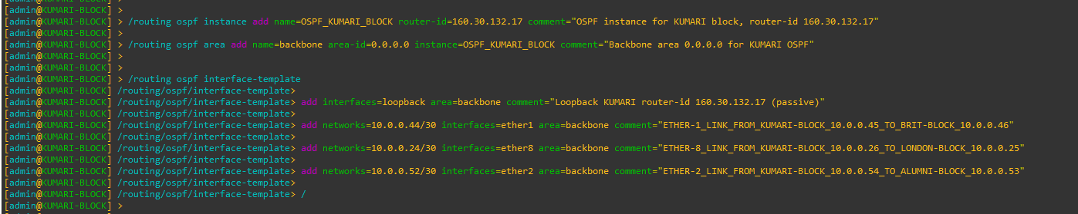

Figure 61: Configuration OSPF to KUMARI-BLOCK Router Through CMD

|  |
| --- |
| Figure 62: Configuration OSPF Instances to KUMARI-BLOCK Router Through WINBOX |
| Figure 63: Configuration OSPF Area to KUMARI-BLOCK Router Through WINBOX |
| Figure 64: Configuration OSPF Interface-template to KUMARI-BLOCK Router Through WINBOX |

# Configure Management Access from PC to MPLS Loopback

## PC (VMware Host) – Static Route Configuration

To allow the PC (VMware host) to reach the MPLS loopback network

160.30.132.0/24, a persistent static route is added on the PC pointing to the

LONDON-BLOCK management interface.

CMD (Windows PC)

|  |
| --- |
| route -p add 160.30.132.0 mask 255.255.255.0 192.168.174.173 |



## UK-BLOCK – OSPF Configuration (No Management Network Advertisement)

LONDON-BLOCK acts as the central management gateway between the PC and the MPLS core. UK-BLOCK participates only in MPLS core OSPF.

The VMware management network must not be added to OSPF.

|  |
| --- |
| /routing ospf interface-template  add networks=192.168.174.0/24 interfaces=ether9 area=backbone  / |



## Disable RoMON temporarily to avoid confusion

Cmd

|  |
| --- |
| /tool romon set enabled=no |

## End-to-End Verification (From PC)

Ping Test

|  |
| --- |
| ping 160.30.132.1  ping 160.30.132.11  ping 160.30.132.14  ping 160.30.132.16 |

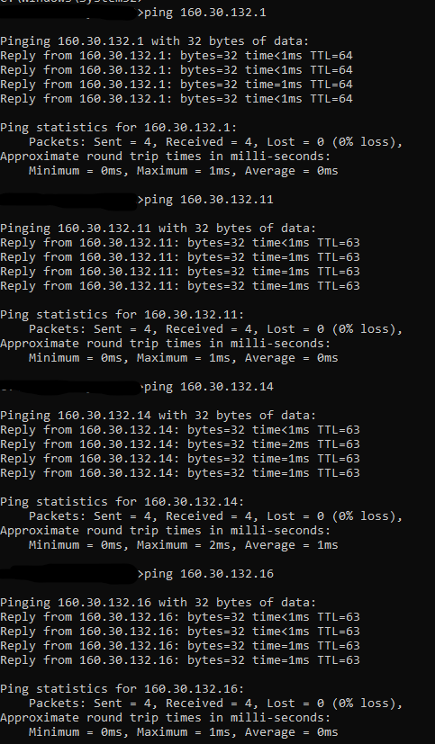

# Configuration MPLS to all Core Routers

## LONDON-BLOCK

CMD

|  |
| --- |
| /mpls ldp add lsr-id=160.30.132.1 transport-addresses=160.30.132.1 comment="Enable MPLS LDP using loopback 160.30.132.1"  /mpls ldp set [find lsr-id=160.30.132.1] disabled=no comment="Enable MPLS LDP using loopback 160.30.132.1" |



Figure 65: Configuration MPLS to LONDON-BLOCK Router Through CMD

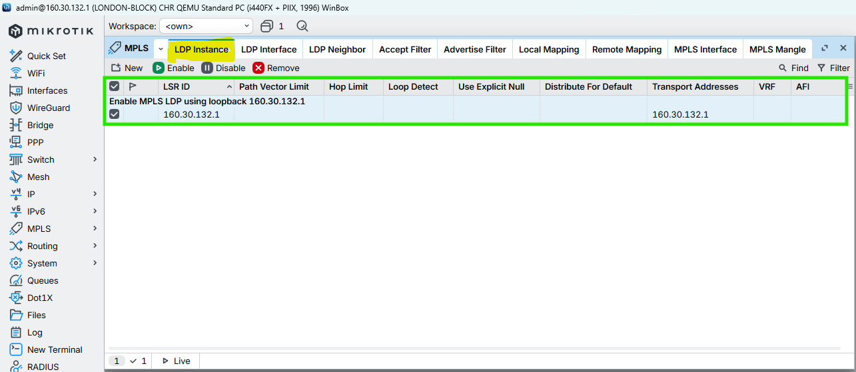

Figure 66: Configuration MPLS to LONDON-BLOCK Router Through WINBOX

## UK-BLOCK

CMD

|  |
| --- |
| /mpls ldp add lsr-id=160.30.132.11 transport-addresses=160.30.132.11 comment="Enable MPLS LDP using loopback 160.30.132.11"  /mpls ldp set [find lsr-id=160.30.132.11] disabled=no comment="Enable MPLS LDP using loopback 160.30.132.11" |



Figure 67: Configuration MPLS to UK-BLOCK Router Through CMD

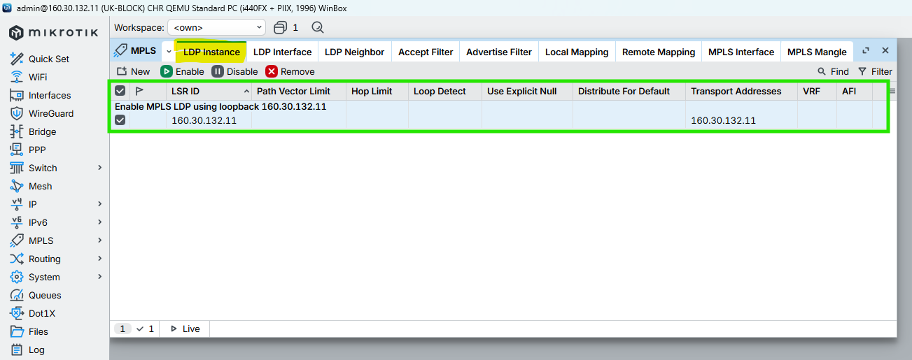

Figure 68: Configuration MPLS to UK-BLOCK Router Through WINBOX

## NEPAL-BLOCK

CMD

|  |
| --- |
| /mpls ldp add lsr-id=160.30.132.12 transport-addresses=160.30.132.12 comment="Enable MPLS LDP using loopback 160.30.132.12"  /mpls ldp set [find lsr-id=160.30.132.12] disabled=no comment="Enable MPLS LDP using loopback 160.30.132.12" |



Figure 69: Configuration MPLS to NEPAL-BLOCK Router Through CMD

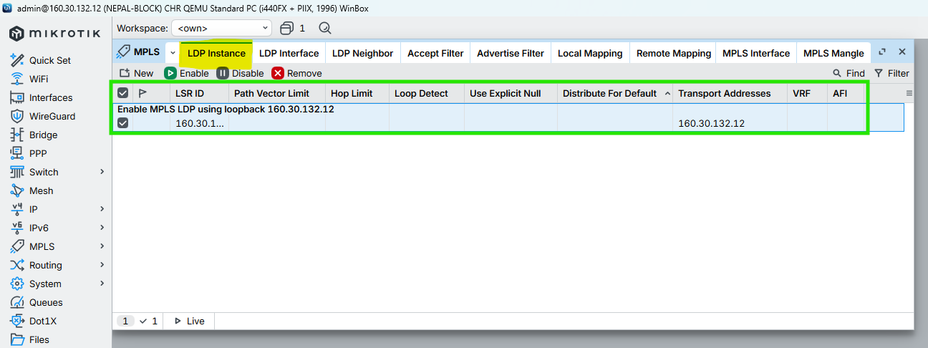

Figure 70: Configuration MPLS to NEPAL-BLOCK Router Through WINBOX

## HIMAL-BLOCK

CMD

|  |
| --- |
| /mpls ldp add lsr-id=160.30.132.13 transport-addresses=160.30.132.13 comment="Enable MPLS LDP using loopback 160.30.132.13"  /mpls ldp set [find lsr-id=160.30.132.13] disabled=no comment="Enable MPLS LDP using loopback 160.30.132.13" |



Figure 71: Configuration MPLS to HIMAL-BLOCK Router Through CMD

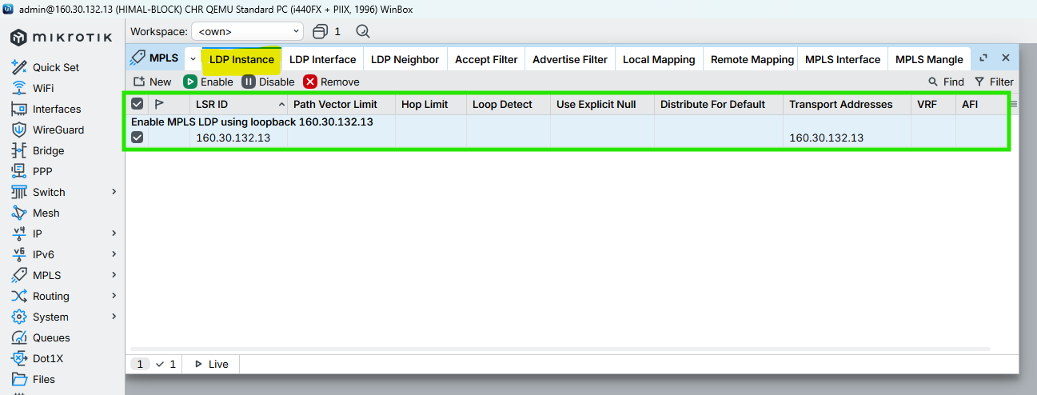

Figure 72: Configuration MPLS to HIMAL-BLOCK Router Through WINBOX

## BRIT-BLOCK

CMD

|  |
| --- |
| /mpls ldp add lsr-id=160.30.132.14 transport-addresses=160.30.132.14 comment="Enable MPLS LDP using loopback 160.30.132.14"  /mpls ldp set [find lsr-id=160.30.132.14] disabled=no comment="Enable MPLS LDP using loopback 160.30.132.14" |



Figure 73: Configuration MPLS to BRIT-BLOCK Router Through CMD

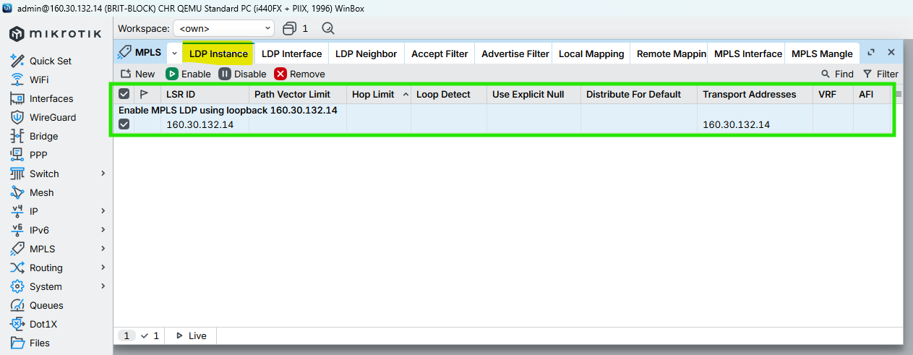

Figure 74: Configuration MPLS to BRIT-BLOCK Router Through WINBOX

## SKILL-BLOCK

CMD

|  |
| --- |
| /mpls ldp add lsr-id=160.30.132.15 transport-addresses=160.30.132.15 comment="Enable MPLS LDP using loopback 160.30.132.15"  /mpls ldp set [find lsr-id=160.30.132.15] disabled=no comment="Enable MPLS LDP using loopback 160.30.132.15" |



Figure 75: Configuration MPLS to SKILL-BLOCK Router Through CMD

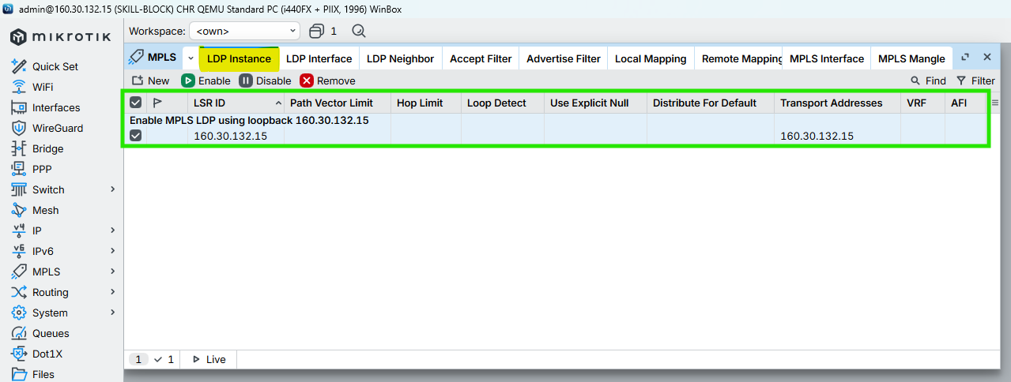

Figure 76: Configuration MPLS to SKILL-BLOCK Router Through WINBOX

## ALUMNI-BLOCK

CMD

|  |
| --- |
| /mpls ldp add lsr-id=160.30.132.16 transport-addresses=160.30.132.16 comment="Enable MPLS LDP using loopback 160.30.132.16"  /mpls ldp set [find lsr-id=160.30.132.16] disabled=no comment="Enable MPLS LDP using loopback 160.30.132.16" |



Figure 77: Configuration MPLS to ALUMNI-BLOCK Router Through CMD

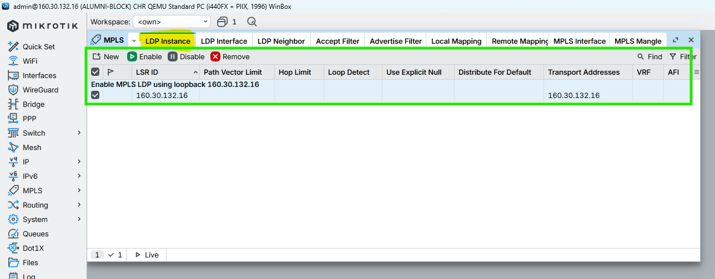

Figure 78: Configuration MPLS to ALUMNI-BLOCK Router Through WINBOX

## KUMARI-BLOCK

CMD

|  |
| --- |
| /mpls ldp add lsr-id=160.30.132.17 transport-addresses=160.30.132.17 comment="Enable MPLS LDP using loopback 160.30.132.17"  /mpls ldp set [find lsr-id=160.30.132.17] disabled=no comment="Enable MPLS LDP using loopback 160.30.132.17" |



Figure 79: Configuration MPLS to KUMARI-BLOCK Router Through CMD

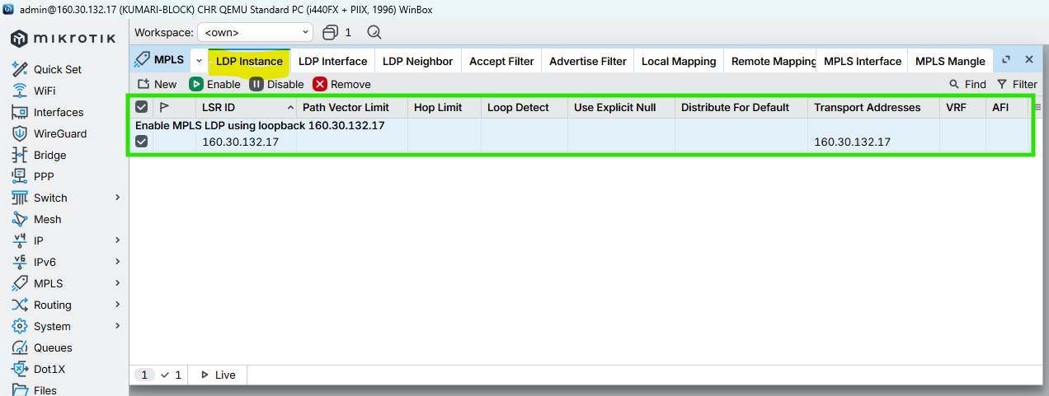

Figure 80: Configuration MPLS to KUMARI-BLOCK Router Through CMD

# MPLS & LDP Configuration on Core Interfaces (with MTU)

This section enables LDP signaling, MPLS forwarding, and configures MPLS MTU (1508) on all core-facing interfaces only to support VPLS without fragmentation.

## LONDON-BLOCK

### Enable LDP on Core Interfaces ONLY

CMD

|  |
| --- |
| /mpls ldp interface  add interface=ether2 comment="LDP_CORE_LINK_LONDON-BLOCK_10.0.0.1/30_TO_UK-BLOCK_10.0.0.2/30"  add interface=ether3 comment="LDP_CORE_LINK_LONDON-BLOCK_10.0.0.5/30_TO_NEPAL-BLOCK_10.0.0.6/30"  add interface=ether4 comment="LDP_CORE_LINK_LONDON-BLOCK_10.0.0.9/30_TO_HIMAL-BLOCK_10.0.0.10/30"  add interface=ether5 comment="LDP_CORE_LINK_LONDON-BLOCK_10.0.0.13/30_TO_BRIT-BLOCK_10.0.0.14/30"  add interface=ether6 comment="LDP_CORE_LINK_LONDON-BLOCK_10.0.0.17/30_TO_SKILL-BLOCK_10.0.0.18/30"  add interface=ether7 comment="LDP_CORE_LINK_LONDON-BLOCK_10.0.0.21/30_TO_ALUMNI-BLOCK_10.0.0.22/30"  add interface=ether8 comment="LDP_CORE_LINK_LONDON-BLOCK_10.0.0.25/30_TO_KUMARI-BLOCK_10.0.0.26/30"  / |

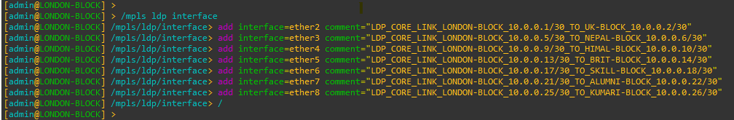

Figure 81: Configuration MPLS LDP Interfaces to LONDON-BLOCK Router Through CMD

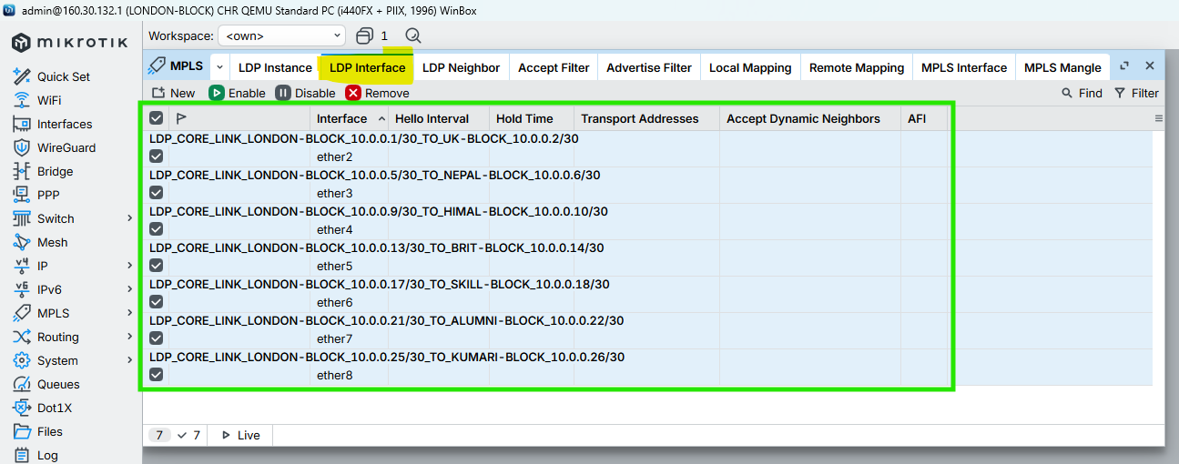

Figure 82: Configuration MPLS LDP nterfaces to LONDON-BLOCK Router Through WINBOX

### Enable MPLS & Set MPLS MTU on interfaces

CMD

|  |
| --- |
| /mpls interface  add interface=ether2 mpls-mtu=1508 comment="MPLS_CORE_LINK_LONDON-BLOCK_TO_UK-BLOCK_MTU1508"  add interface=ether3 mpls-mtu=1508 comment="MPLS_CORE_LINK_LONDON-BLOCK_TO_NEPAL-BLOCK_MTU1508"  add interface=ether4 mpls-mtu=1508 comment="MPLS_CORE_LINK_LONDON-BLOCK_TO_HIMAL-BLOCK_MTU1508"  add interface=ether5 mpls-mtu=1508 comment="MPLS_CORE_LINK_LONDON-BLOCK_TO_BRIT-BLOCK_MTU1508"  add interface=ether6 mpls-mtu=1508 comment="MPLS_CORE_LINK_LONDON-BLOCK_TO_SKILL-BLOCK_MTU1508"  add interface=ether7 mpls-mtu=1508 comment="MPLS_CORE_LINK_LONDON-BLOCK_TO_ALUMNI-BLOCK_MTU1508"  add interface=ether8 mpls-mtu=1508 comment="MPLS_CORE_LINK_LONDON-BLOCK_TO_KUMARI-BLOCK_MTU1508"  / |

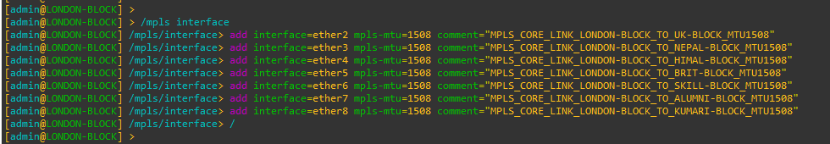

Figure 83: Configuration MPLS MTU on Interfaces to LONDON-BLOCK Router Through CMD

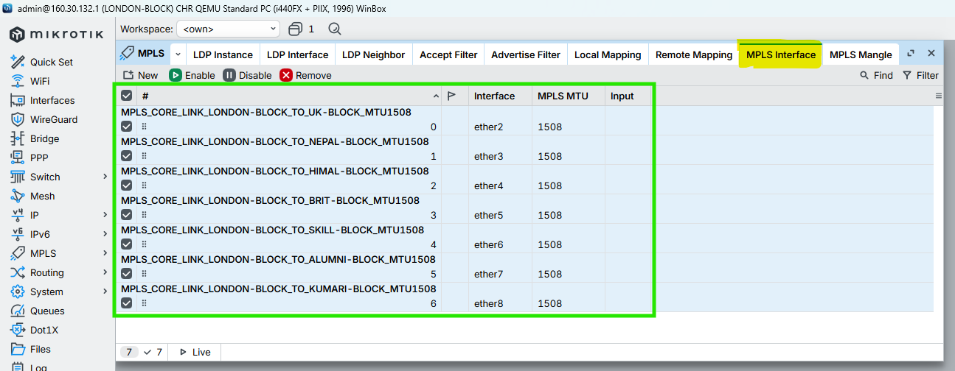

Figure 84: Configuration MPLS MTU on Interfaces to LONDON-BLOCK Router Through WINBOX

## UK-BLOCK

### Enable LDP on Core Interfaces ONLY

CMD

|  |
| --- |
| /mpls ldp interface  add interface=ether2 comment="LDP_CORE_LINK_UK-BLOCK_10.0.0.2/30_TO_LONDON-BLOCK_10.0.0.1/30"  add interface=ether1 comment="LDP_CORE_LINK_UK-BLOCK_10.0.0.29/30_TO_NEPAL-BLOCK_10.0.0.30/30"  add interface=ether3 comment="LDP_CORE_LINK_UK-BLOCK_10.0.0.34/30_TO_HIMAL-BLOCK_10.0.0.33/30"  / |

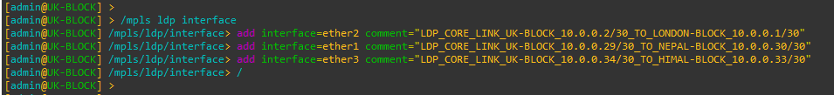

Figure 85: Configuration MPLS LDP Interfaces to UK-BLOCK Router Through CMD

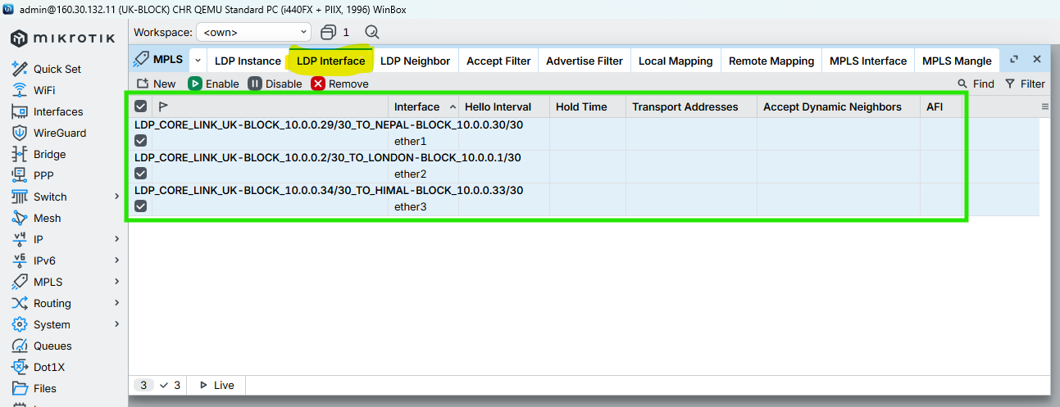

Figure 86: Configuration MPLS LDP Interfaces to UK-BLOCK Router Through WINBOX

### Enable MPLS & Set MPLS MTU on interfaces

CMD

|  |
| --- |
| /mpls interface  add interface=ether2 mpls-mtu=1508 comment="MPLS_CORE_LINK_UK-BLOCK_TO_LONDON-BLOCK_MTU1508"  add interface=ether1 mpls-mtu=1508 comment="MPLS_CORE_LINK_UK-BLOCK_TO_NEPAL-BLOCK_MTU1508"  add interface=ether3 mpls-mtu=1508 comment="MPLS_CORE_LINK_UK-BLOCK_TO_HIMAL-BLOCK_MTU1508"  / |

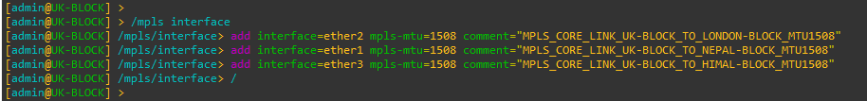

Figure 87: Configuration MPLS MTU on Interfaces to UK-BLOCK Router Through CMD

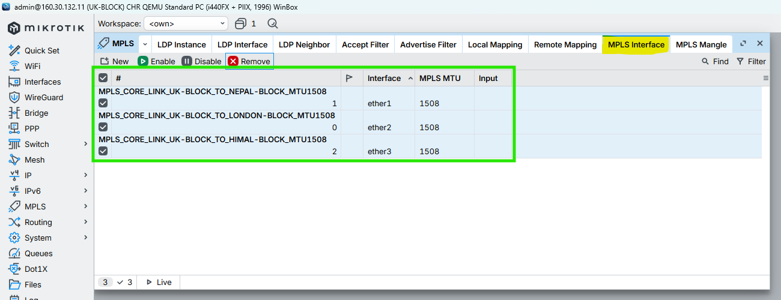

Figure 88: Configuration MPLS MTU on Interfaces to UK-BLOCK Router Through WINBOX

## NEPAL-BLOCK

### Enable LDP on Core Interfaces ONLY

CMD

|  |
| --- |
| /mpls ldp interface  add interface=ether3 comment="LDP_CORE_LINK_NEPAL-BLOCK_10.0.0.6/30_TO_LONDON-BLOCK_10.0.0.5/30"  add interface=ether1 comment="LDP_CORE_LINK_NEPAL-BLOCK_10.0.0.30/30_TO_UK-BLOCK_10.0.0.29/30"  add interface=ether2 comment="LDP_CORE_LINK_NEPAL-BLOCK_10.0.0.37/30_TO_BRIT-BLOCK_10.0.0.38/30"  / |

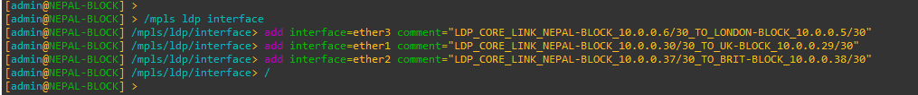

Figure 89: Configuration MPLS LDP Interfaces to NEPAL-BLOCK Router Through CMD

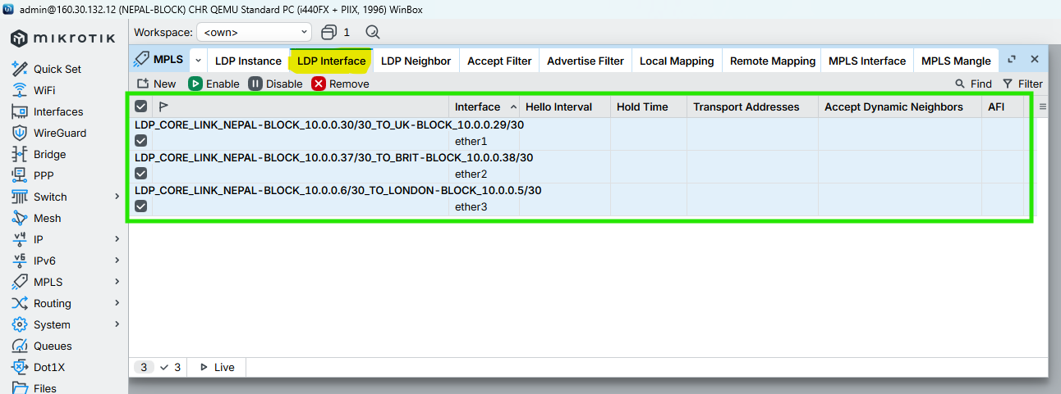

Figure 90: Configuration MPLS LDP Interfaces to NEPAL-BLOCK Router Through WINBOX

### Enable MPLS & Set MPLS MTU on interfaces

CMD

|  |
| --- |
| /mpls interface  add interface=ether3 mpls-mtu=1508 comment="MPLS_CORE_LINK_NEPAL-BLOCK_TO_LONDON-BLOCK_MTU1508"  add interface=ether1 mpls-mtu=1508 comment="MPLS_CORE_LINK_NEPAL-BLOCK_TO_UK-BLOCK_MTU1508"  add interface=ether2 mpls-mtu=1508 comment="MPLS_CORE_LINK_NEPAL-BLOCK_TO_BRIT-BLOCK_MTU1508"  / |

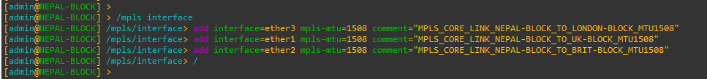

Figure 91: Configuration MPLS MTU on Interfaces to NEPAL-BLOCK Router Through CMD

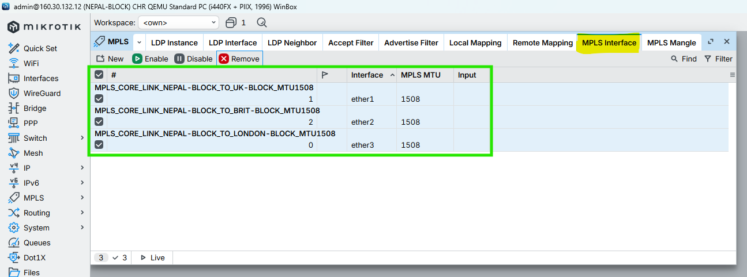

Figure 92: Configuration MPLS MTU on Interfaces to NEPAL-BLOCK Router Through WINBOX

## HIMAL-BLOCK

### Enable LDP on Core Interfaces ONLY

CMD

|  |
| --- |
| /mpls ldp interface  add interface=ether3 comment="LDP_CORE_LINK_HIMAL-BLOCK_10.0.0.33/30_TO_UK-BLOCK_10.0.0.34/30"  add interface=ether4 comment="LDP_CORE_LINK_HIMAL-BLOCK_10.0.0.10/30_TO_LONDON-BLOCK_10.0.0.9/30"  add interface=ether2 comment="LDP_CORE_LINK_HIMAL-BLOCK_10.0.0.42/30_TO_SKILL-BLOCK_10.0.0.41/30"  / |

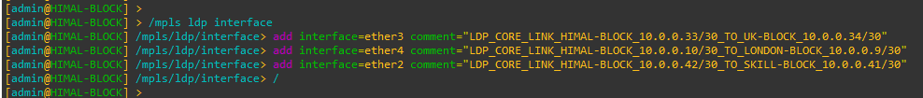

Figure 93: Configuration MPLS LDP Interfaces to HIMAL-BLOCK Router Through CMD

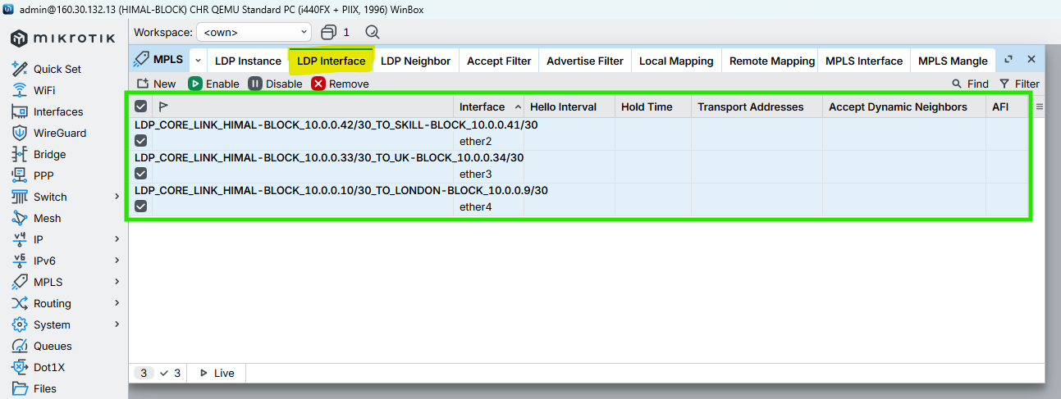

Figure 94: Configuration MPLS LDP Interfaces to HIMAL-BLOCK Router Through WINBOX

### Enable MPLS & Set MPLS MTU on interfaces

CMD

|  |
| --- |
| /mpls interface  add interface=ether3 mpls-mtu=1508 comment="MPLS_CORE_LINK_HIMAL-BLOCK_TO_UK-BLOCK_MTU1508"  add interface=ether4 mpls-mtu=1508 comment="MPLS_CORE_LINK_HIMAL-BLOCK_TO_LONDON-BLOCK_MTU1508"  add interface=ether2 mpls-mtu=1508 comment="MPLS_CORE_LINK_HIMAL-BLOCK_TO_SKILL-BLOCK_MTU1508"  / |

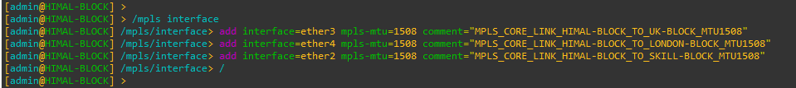

Figure 95: Configuration MPLS MTU on Interfaces to HIMAL-BLOCK Router Through CMD

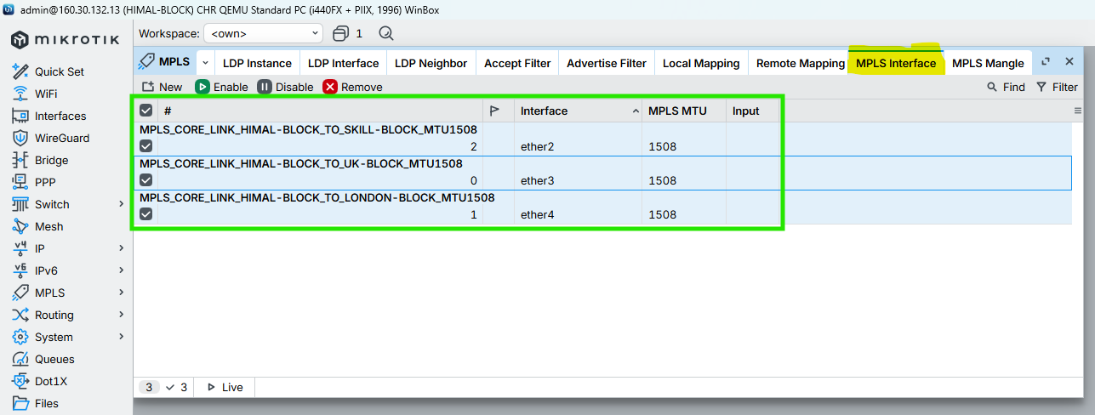

Figure 96: Configuration MPLS MTU on Interfaces to HIMAL-BLOCK Router Through WINBOX

## BRIT-BLOCK

### Enable LDP on Core Interfaces ONLY

CMD

|  |
| --- |
| /mpls ldp interface  add interface=ether2 comment="LDP_CORE_LINK_BRIT-BLOCK_10.0.0.38/30_TO_NEPAL-BLOCK_10.0.0.37/30"  add interface=ether5 comment="LDP_CORE_LINK_BRIT-BLOCK_10.0.0.14/30_TO_LONDON-BLOCK_10.0.0.13/30"  add interface=ether1 comment="LDP_CORE_LINK_BRIT-BLOCK_10.0.0.46/30_TO_KUMARI-BLOCK_10.0.0.44/30"  / |

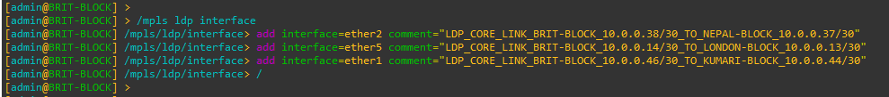

Figure 97: Configuration MPLS LDP Interfaces to BRIT-BLOCK Router Through CMD

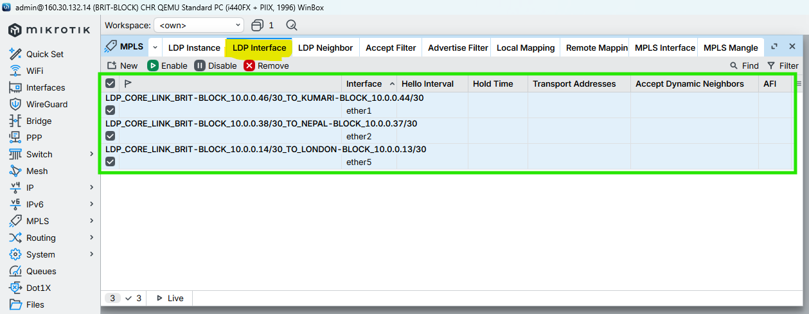

Figure 98: Configuration MPLS LDP Interfaces to BRIT-BLOCK Router Through WINBOX

### Enable MPLS & Set MPLS MTU on interfaces

CMD

|  |
| --- |
| /mpls interface  add interface=ether2 mpls-mtu=1508 comment="MPLS_CORE_LINK_BRIT-BLOCK_TO_NEPAL-BLOCK_MTU1508"  add interface=ether5 mpls-mtu=1508 comment="MPLS_CORE_LINK_BRIT-BLOCK_TO_LONDON-BLOCK_MTU1508"  add interface=ether1 mpls-mtu=1508 comment="MPLS_CORE_LINK_BRIT-BLOCK_TO_KUMARI-BLOCK_MTU1508"  / |

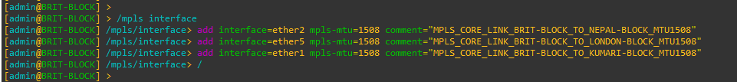

Figure 99: Configuration MPLS MTU on Interfaces to BRIT-BLOCK Router Through CMD

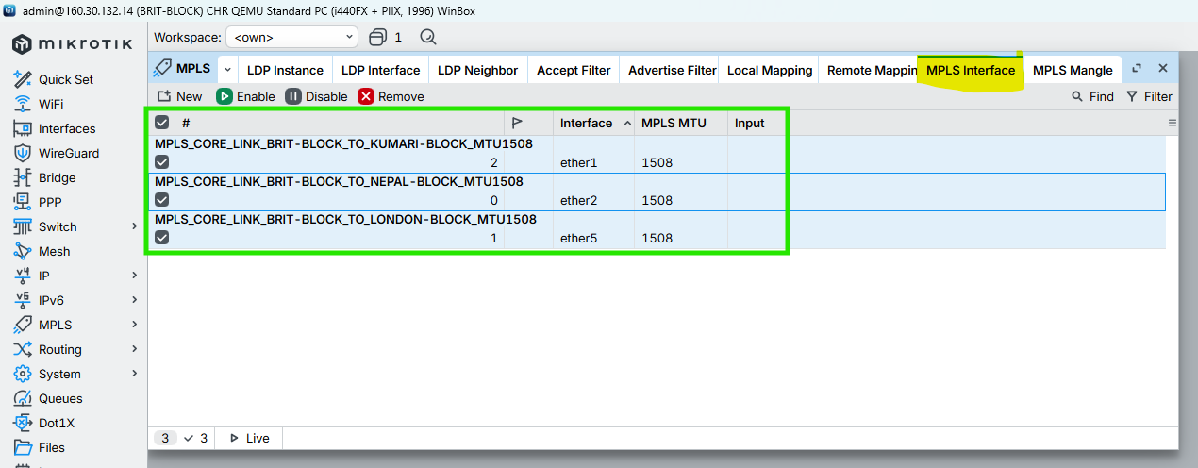

Figure 100: Configuration MPLS MTU on Interfaces to BRIT-BLOCK Router Through WINBOX

## SKILL-BLOCK

### Enable LDP on Core Interfaces ONLY

CMD

|  |
| --- |
| /mpls ldp interface  add interface=ether2 comment="LDP_CORE_LINK_SKILL-BLOCK_10.0.0.41/30_TO_HIMAL-BLOCK_10.0.0.42/30"  add interface=ether6 comment="LDP_CORE_LINK_SKILL-BLOCK_10.0.0.18/30_TO_LONDON-BLOCK_10.0.0.17/30"  add interface=ether1 comment="LDP_CORE_LINK_SKILL-BLOCK_10.0.0.50/30_TO_KUMARI-BLOCK_10.0.0.49/30"  / |

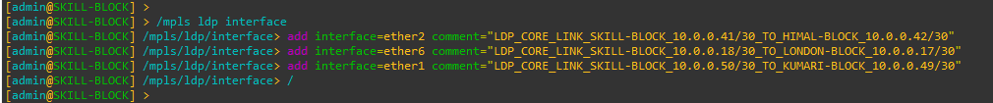

Figure 101: Configuration MPLS LDP Interfaces to SKILL-BLOCK Router Through CMD

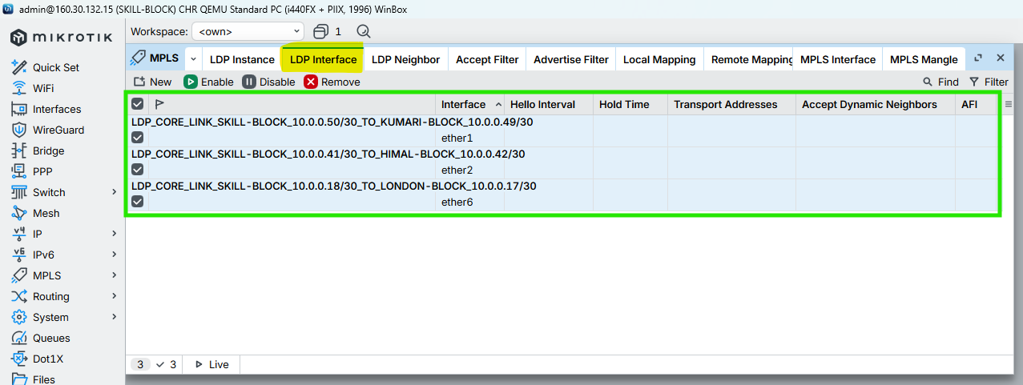

Figure 102: Configuration MPLS LDP Interfaces to SKILL-BLOCK Router Through WINBOX

### Enable MPLS & Set MPLS MTU on interfaces

CMD

|  |
| --- |
| /mpls interface  add interface=ether2 mpls-mtu=1508 comment="MPLS_CORE_LINK_SKILL-BLOCK_TO_HIMAL-BLOCK_MTU1508"  add interface=ether6 mpls-mtu=1508 comment="MPLS_CORE_LINK_SKILL-BLOCK_TO_LONDON-BLOCK_MTU1508"  add interface=ether1 mpls-mtu=1508 comment="MPLS_CORE_LINK_SKILL-BLOCK_TO_KUMARI-BLOCK_MTU1508"  / |

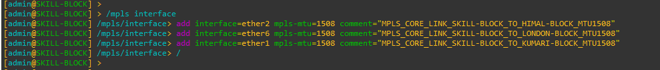

Figure 103: Configuration MPLS MTU on Interfaces to SKILL-BLOCK Router Through CMD

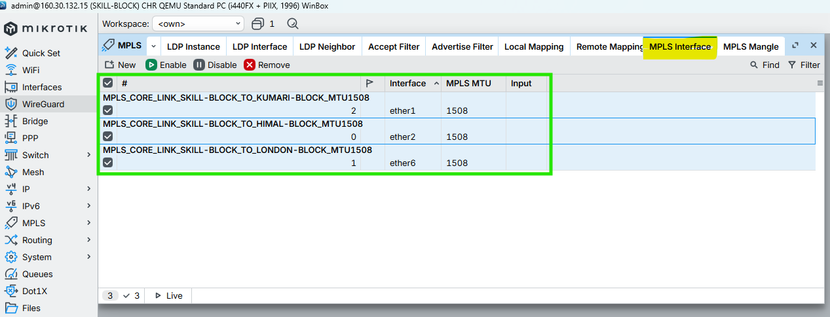

Figure 104: Configuration MPLS MTU on Interfaces to SKILL-BLOCK Router Through WINBOX\

## ALUMNI-BLOCK

### Enable LDP on Core Interfaces ONLY

CMD

|  |
| --- |
| /mpls ldp interface  add interface=ether7 comment="LDP_CORE_LINK_ALUMNI-BLOCK_10.0.0.22/30_TO_LONDON-BLOCK_10.0.0.21/30"  add interface=ether1 comment="LDP_CORE_LINK_ALUMNI-BLOCK_10.0.0.49/30_TO_SKILL-BLOCK_10.0.0.50/30"  add interface=ether2 comment="LDP_CORE_LINK_ALUMNI-BLOCK_10.0.0.53/30_TO_KUMARI-BLOCK_10.0.0.54/30"  / |

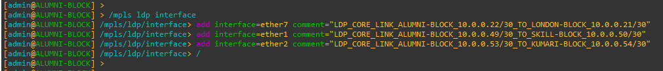

Figure 105: Configuration MPLS LDP Interfaces to ALUMNI-BLOCK Router Through CMD

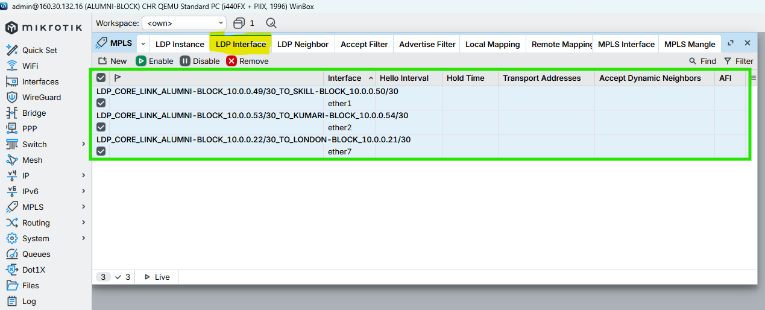

Figure 106: Configuration MPLS LDP Interfaces to ALUMNI-BLOCK Router Through WINBOX

### Enable MPLS & Set MPLS MTU on interfaces

CMD

|  |
| --- |
| /mpls interface  add interface=ether7 mpls-mtu=1508 comment="MPLS_CORE_LINK_ALUMNI-BLOCK_TO_LONDON-BLOCK_MTU1508"  add interface=ether1 mpls-mtu=1508 comment="MPLS_CORE_LINK_ALUMNI-BLOCK_TO_SKILL-BLOCK_MTU1508"  add interface=ether2 mpls-mtu=1508 comment="MPLS_CORE_LINK_ALUMNI-BLOCK_TO_KUMARI-BLOCK_MTU1508"  / |

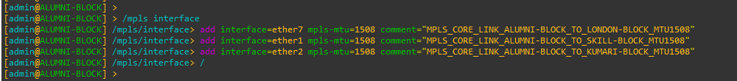

Figure 107: Configuration MPLS MTU on Interfaces to ALUMNI-BLOCK Router Through CMD

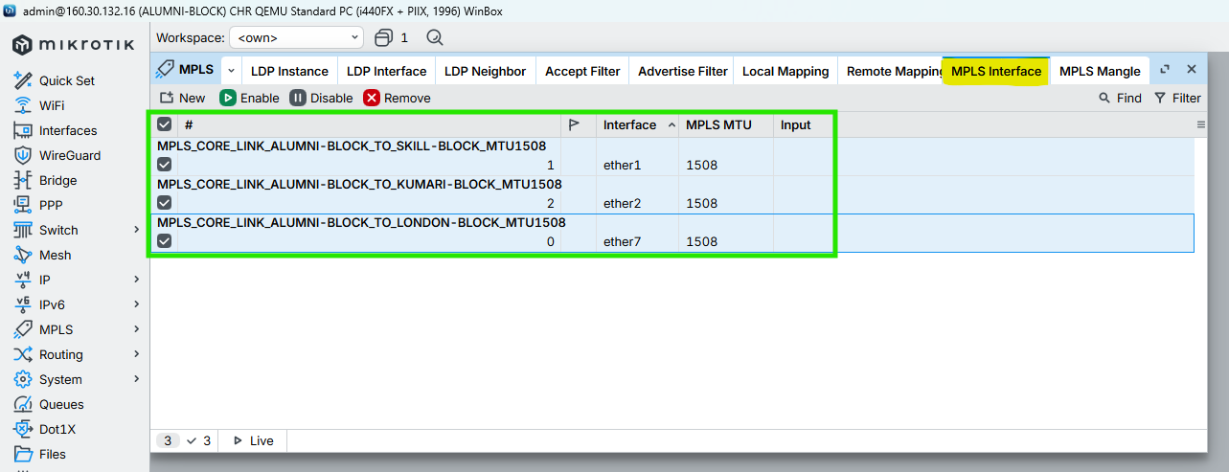

Figure 108: Configuration MPLS MTU on Interfaces to ALUMNI-BLOCK Router Through WINBOX

## KUMARI-BLOCK

### Enable LDP on Core Interfaces ONLY

CMD

|  |
| --- |
| /mpls ldp interface  add interface=ether8 comment="LDP_CORE_LINK_KUMARI-BLOCK_10.0.0.26/30_TO_LONDON-BLOCK_10.0.0.25/30"  add interface=ether2 comment="LDP_CORE_LINK_KUMARI-BLOCK_10.0.0.54/30_TO_ALUMNI-BLOCK_10.0.0.53/30"  add interface=ether1 comment="LDP_CORE_LINK_KUMARI-BLOCK_10.0.0.44/30_TO_BRIT-BLOCK_10.0.0.46/30"  / |

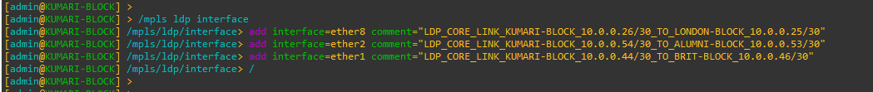

Figure 109: Configuration MPLS LDP Interfaces to KUMARI-BLOCK Router Through CMD

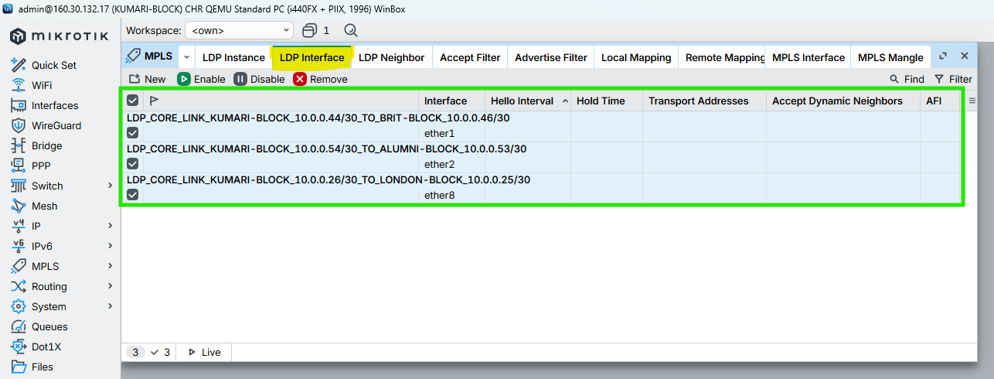

Figure 110: Configuration MPLS LDP Interfaces to KUMARI-BLOCK Router Through WINBOX

### Enable MPLS & Set MPLS MTU on interfaces

CMD

|  |
| --- |
| /mpls interface  add interface=ether8 mpls-mtu=1508 comment="MPLS_CORE_LINK_KUMARI-BLOCK_TO_LONDON-BLOCK_MTU1508"  add interface=ether2 mpls-mtu=1508 comment="MPLS_CORE_LINK_KUMARI-BLOCK_TO_ALUMNI-BLOCK_MTU1508"  add interface=ether1 mpls-mtu=1508 comment="MPLS_CORE_LINK_KUMARI-BLOCK_TO_BRIT-BLOCK_MTU1508"  / |

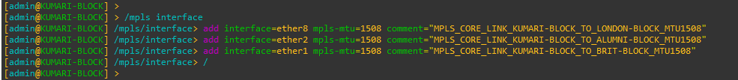

Figure 111: Configuration MPLS MTU on Interfaces to KUMARI-BLOCK Router Through CMD

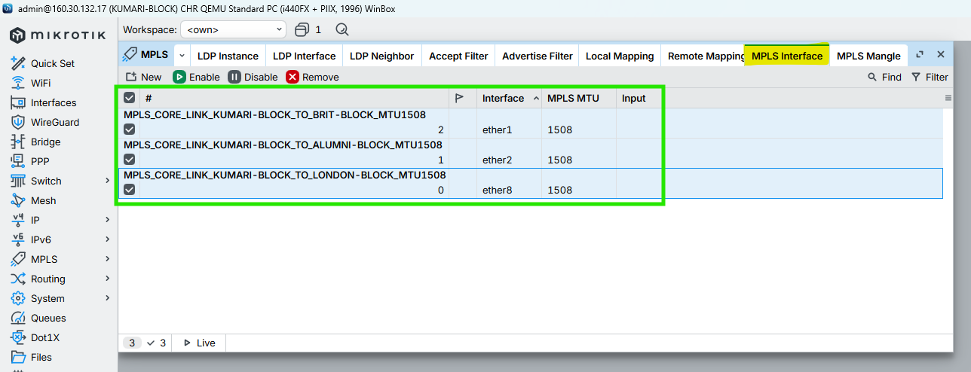

Figure 112: Configuration MPLS MTU on Interfaces to KUMARI-BLOCK Router Through WINBOX